Low Level Concern Policy
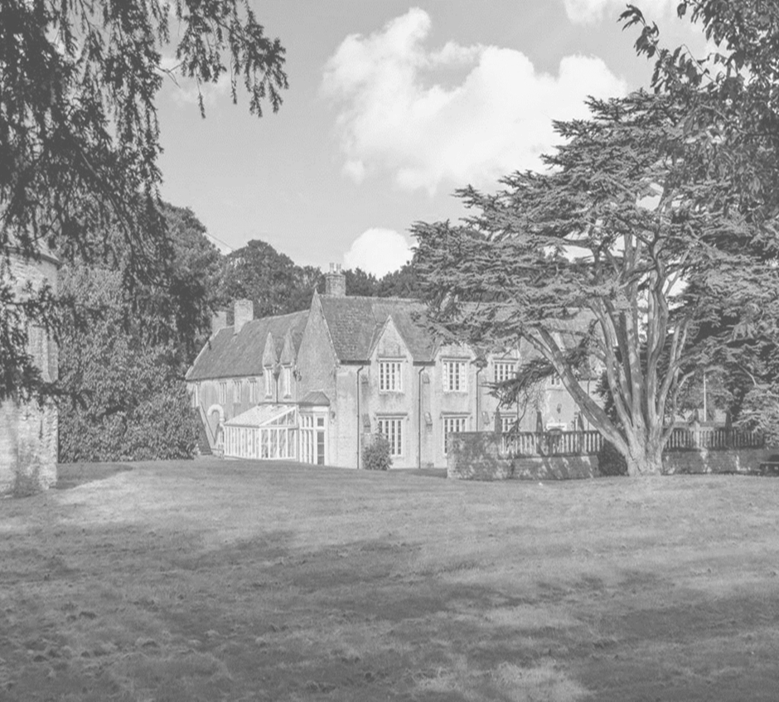
Approved by: | Neil Gage | Date: 1st September 2025
Last reviewed on: | 1st August 2025
Next review due by: | 1st August 2026

1. Statement of Intent
Dovecote School is committed to safeguarding and promoting the welfare of all pupils. This includes creating a culture of openness and transparency where concerns about the behaviour of adults working with children are identified and addressed promptly.
This policy sets out how the school manages low-level concerns in line with:
- Keeping Children Safe in Education (DfE, 2025)
- The Independent School Standards
A low-level concern does not meet the threshold for referral to the Local Authority Designated Officer (LADO), but may indicate that an adult is acting in a way that:
- Is inconsistent with the staff code of conduct
- May not be in the best interests of pupils
- Could escalate into more serious concerns if unaddressed

2. Definition of a Low-Level Concern
A low-level concern is any concern, no matter how small, about an adult working in or on behalf of the school that causes a sense of unease or doubt.
Examples may include:
- Being overly friendly with pupils
- Using inappropriate language or tone
- Not maintaining appropriate professional boundaries
- Favouritism or inconsistent behaviour
- Inappropriate use of social media or communication
This list is not exhaustive.

3. Creating a Safe Reporting Culture
Dovecote School promotes a culture where:
- Staff feel confident to report concerns without fear of reprisal
- Concerns are taken seriously and handled sensitively
- Professional curiosity is encouraged
All staff understand that reporting low-level concerns is a safeguarding responsibility and part of maintaining a safe environment for pupils.

4. Reporting a Low-Level Concern
Low-level concerns should be reported to the Headteacher as soon as possible.
Where the concern relates to the Headteacher, it should be reported to the Proprietor Body.
Concerns should:
- Be reported promptly
- Include factual information
- Avoid speculation or assumptions

5. Recording and Management
The Headteacher will:
- Record all low-level concerns in a secure and confidential manner
- Review patterns or repeated concerns
- Determine appropriate action
Actions may include:
- Informal discussion with the individual
- Additional guidance or training
- Monitoring or supervision
Records will be kept in accordance with data protection requirements and safeguarding procedures.

6. Distinguishing from Allegations
Low-level concerns differ from allegations that meet the harm threshold.
Where a concern suggests:
- Harm to a child
- Possible criminal offence
- Behaviour that may pose a risk to children
The matter will be managed in line with the Safeguarding and Child Protection Policy, including referral to the LADO where appropriate.

7. Staff Training and Awareness
All staff:
- Receive safeguarding training including low-level concerns
- Are made aware of this policy at induction
- Receive regular updates in line with KCSIE 2025

8. Confidentiality
Low-level concerns will be handled with appropriate confidentiality.
Information will be shared only where necessary to:
- Safeguard pupils
- Support appropriate management action

9. Monitoring and Oversight
The Headteacher and Proprietor Body will:
- Monitor the number and nature of concerns
- Ensure appropriate action is taken
- Review the effectiveness of the policy

10. Linked Policies
This policy should be read alongside:
- Safeguarding and Child Protection Policy
- Staff Code of Conduct
- Whistleblowing Policy
Next Review: 01/08/2026
Responsible Person: Headteacher / DSL

