Dovecote school: Curriculum Statement

Curriculum Intent
At Dovecote School, we deliver an exciting and innovative curriculum, specifically developed to meet the needs of students with varied different SEN difficulties. The overall purpose of our curriculum is to prepare students for adulthood through a positive and supportive framework that helps to Develop learners who are.
- Confident learners -Who can identify with themselves who lead safe, healthy, and fulfilling lives.
- Successful learners - who enjoy school, make great progress, and achieve a range of qualifications based on appropriate outcomes who are ready to integrate back into mainstream provisions in primary, secondary, or tertiary education.
- Responsible individuals - Who make productive contributions to democratic society and follow the rule of law.
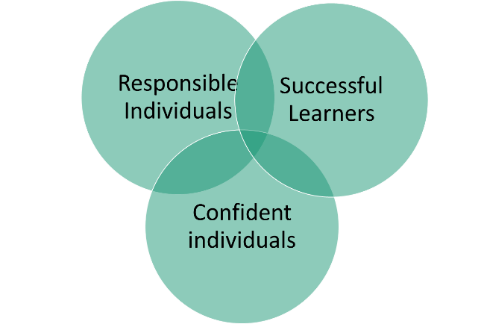

Dovecote School will follow the National Curriculum and offer a broad and balanced curriculum that ensures our students develop the essential skills in reading, writing, oracy, and numeracy. The curriculum will provide a full and rounded entitlement to learning. It will foster Students’ creativity and develop essential skills, including independent learning skills that transfer to a desire for lifelong learning. The curriculum will promote a healthy and safe lifestyle underpinned by an understanding of community cohesion and the five fundamental British values of; democracy, the rule of law, individual liberty, and mutual respect and acceptance of those with different faiths and beliefs.

Curriculum Implementation
At Dovecote school, the personalised curriculum and range of approaches and learning styles will have a focus on effective communication to enhance social and emotional wellbeing.
When students start at Dovecote the focus of education is to create a feeling of feeling safe, special, and secure. This is achieved by staff working therapeutically to meet needs. As students develop into the Doing staff collaborate with students co adventuring. It is at this stage we add in supportive initiatives, Salt & OT direction. As student mov on into the Thinking stage, students access the national curriculum, life skills courses and the specific target interventions. Students transition vary between stage.

When in more formal learning, differentiated planning will consider emotional regulation, and interventions that need to be included to promote a love for learning. This will lead to academic and social progress. Physical and sensory needs are also taken into consideration, we will look for discrete ways in which children can learn skills alongside their acquisition of knowledge, ensuring that both are developed.
Prior learning will be gained through effective assessment and data reporting and collection this is reflected in the regular reinforcement of key skills and knowledge. Our themed and topic-based approach means that that many skills are reinforced because of cross-curricular teaching in the context of many other subjects, including after school clubs and an Outdoor Enrichment curriculum.
We aim for a depth of learning and breadth of coverage, were excellent staff subject knowledge links components of knowledge to broader, conceptual learning. Opportunities to practice skills and knowledge are built into the curriculum to secure a deep understanding of what Students have been taught and to integrate new knowledge into larger concepts.
Team curriculum planning will lead to a layering of knowledge and concepts delivered in a range of styles so that all Students can make progress. Staff systematically check Student’s understanding to identify gaps in learning and misconceptions. This provides clear feedback for ways forward so that the student to makes progress. Clearly set out ‘I can’ statements and success criteria are used to gain intended learning outcomes and elicit valuable Student self-assessment.
Effective questioning techniques develop higher order thinking skills and support the retention of knowledge and understanding, as staff strive to offer as many recall and application activities as possible. We regularly refer to current research and use the new findings to update our own practice and improve our skills to support our students and their varying needs.
We will use a variety of interventions to support emotional literacy skills with regular sessions timetabled to nurture positive mental health so that learning can continue successfully. We will have excellent home/school links and specialist roles such as our Family Inclusion and Liaison Lead who helps to support all aspects of family life through regular 1:1 support and through our parent’s meetings where help and advice is given as needs arise.
We actively consider the health and well-being of Students, and their families and staff make an extra effort to include families in decisions that affect their children. Staff will seek and take advice from families and outside agencies to see how best to support our children, so that we can have the best outcomes for their futures and nurture their progress.
Through our exciting, stimulating, and creative curriculum we aim for every Student to enjoy learning and gain knowledge, skills and attributes which will enable them to lead happy, fulfilling, and successful lives in the future. We live in an ever-changing world, and it is our aim to ensure that our students are ready to face these challenges and succeed in whatever they do.

We take every opportunity to enrich the curriculum with outside providers, trips and visits, celebration days, whole school themed weeks and extra–curricular opportunities (ODE, wildlife adventures, Bird protection group, IT club, drama club and cooking club). This gives context to learning and shows our students that education is relevant, fun, and worthwhile
Curriculum Impact
The intention of the multi-faceted curriculum is for children to make excellent progress during their time at Dovecote School, academically, socially, and personally transforming their lives and giving them hope for the future.
Subject leaders will regularly share data about their subjects with children, parents, and staff, celebrating the many examples of progress and success because of the effort undertaken by our students, staff, and family support.

At our school, we learn together that there are different pathways to success and develop perseverance by overcoming barriers. This is reflected across all curriculum areas. We understand that ‘getting stuck’ means that personal development and learning is taking place, and this is just part of the journey to success. Our School will teach our children that failure is a part of the learning process which ensures that deep rooted learning which can eventually be applied.

Thorough the scrutiny of subject data, staff can plan further interventions as needed with the quality of teaching regularly monitored through collaborative learning walks, book scrutiny and lesson observations. At Dovecote School we will regularly undertake Student, parent, and staff surveys to monitor and improve our practice, to develop Students who thrive during their time at school and to encourage meaningful, happy, and fulfilling futures for all.

At the end of our student’s journey with Dovecote school we would expect them to be independent learners who are ready to transition into either further and or higher education, work placement or apprenticeships. We expect students to be able to be responsible in the wider world, confident in themselves and surroundings and have successfully gaining national recognised certificate/s of education, and personal achievements with social, emotional developments, as well as hold the correct life skills to live independent life.

