Curriculum Policy
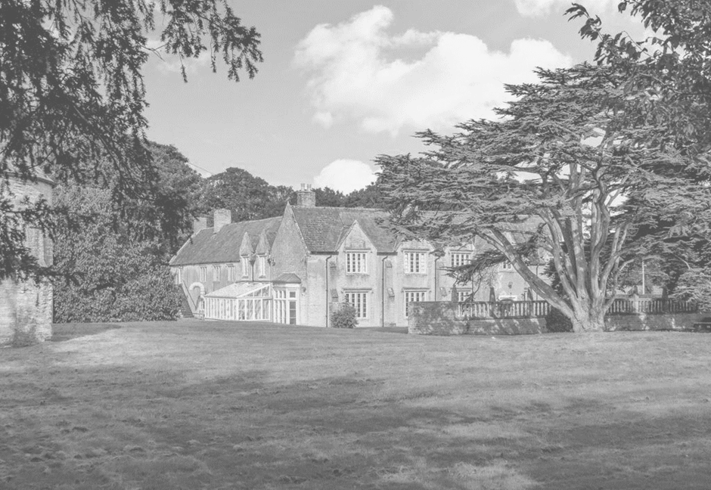
Signed by:
Neil Gage | Headteacher | Date: | 20.03.2023
Jason Goddard | CEO | Date: | 20.03.2023

Contents:
Statement of intent
- Legal framework
- Curriculum intent
- Roles and responsibilities
- PSHE
- Careers education
- Reporting and assessment
- Equal opportunities
- Supporting students with SEND
- Monitoring and review

Statement of intent
Dovecote School cognises the importance of offering a broad and balanced curriculum which is underpinned by our shared school vision.
Our curriculum consists of activities designed to promote the intellectual, personal, social, physical and cultural development of students. It includes the formal programme of lessons, based on the national curriculum, and the informal programme of extracurricular activities that we organise to enrich students’ experiences of their lives and education.
Through this policy, the school aims to:
- Put students at the centre of all curriculum decisions, putting their needs above those of the school.
- Have a curriculum that is fit for purpose, offering differentiation and personalisation.
- Prepare all students for the next stage of their education and for life in modern society.
- First achieve and then exceed national standards in achievement, attainment and progression.
- Be committed to excellence and continuous improvement.
- Provide courses which meet the needs of students.
- Nurture the talents of all and celebrate success.
- Work with feeder schools to ease transition.
- Involve the stakeholders, including parents, in curriculum development.

Legal framework
This policy has due regard to all relevant legislation and statutory guidance including, but not limited to, the following:
- Children Act 2004
- Education Act 2004
- Equality Act 2010
- DfE (2015) ‘Special educational needs and disability code of practice: 0 to 25 years’
- DfE (2014) ‘The national curriculum in England’
This policy operates in conjunction with the following school policies:
- Secondary Assessment and Examination Policy
- Primary Assessment Policy
- Careers Policy
- Student Equality, Equity, Diversity and Inclusion Policy
- Extended Services Policy
- Homework Policy
- PSHE Policy
- Primary Relationships and Health Education Policy
- Secondary Relationships, Sex and Health Education (RSHE) Policy
- Special Educational Needs and Disabilities (SEND) Policy
- Curriculum Intent Statement

Curriculum intent
At Dovecote School, we deliver an exciting and innovative curriculum, specifically developed to meet the needs of students with varied different SEN difficulties. The overall purpose of our curriculum is to prepare students for adulthood through a positive and supportive framework that helps to develop learners who are:
- A Confident learner -Who can identify with themselves, who lead safe/ healthy and fulfilling lives. Who are confident in the world around them and with themselves knowing strategies and techniques that work for them to support life beyond Dovecote.
- Successful learners - who have enjoy being at school, who have make great progress, and achieve a range of qualifications based on appropriate individualised outcomes relevant to them. Learners who are ready to integrate into tertiary education or apprentices.
- Responsible individuals - Who uphold the 5 key British values (Democracy, rule of law, liberty, mutual respect, & Tolerance). Who make productive contributions to society and are active around these.

Our Curriculum will be delivered within a nurturing environment. The school design offers space, bakeout spaces, indoor/ outdoor and areas that create interest for students (e.g. horticulture, farm, forest school, thrive pods, etc....) The curriculum is delivered by staff that use therapeutic (Thrive) strategies, who promote positive mental health, well-being and who cultivate self-awareness and self esteem as the starting point by making all students feel safe, special and secure. As students develop further the school aim is to to create; responsible, confident and successful (RCS) learners in which we ignite a passion for lifelong learning.
As a school, we aim to provide an exciting, interactive, and engaging curriculum. All aspects of the curriculum are underpinned by high quality resources and technology. Our clear curriculum focus (RCS), ensures that children are offered a range of learning experiences which are challenging, real life and meaningful. This approach enriches learning and life experiences for all our students at the school.
The curriculum is further enriched through a variety of trips, learning outside of the classroom (horticulture, Farm, Forest school, Outdoor education), cross-curricular links visits and theme days, and stimulating and inspiring life experiences. We aim to make purposeful use of our school, local and reginal environments to stimulate, create inquisitive behaviour and provide an opportunity to meet unique interests and talents. All with the aim to ensure that all our children are at the centre of a broad, balanced, and varied learning experiences- relevant to them and their longer-term needs to become RCS.
Subjects taught at Dovecote School;
- ENGLISH
- MATHS
- SCIENCE
- DT-FOOD TECHNOLOGY
- DT- ART
- DRAMA
- DT- RESISTANT MATERIALS
- PE/ SPORT
- SWIMMING
- TOPIC
- PHSE
- OUTDOOR ADVENTURE
- HORTICULTURE
- FARM/ LANDBASED STUDIES
- MODERN FOREIGN LANGUAGES
- HISTORY
- GEOGRAPHY
- THRIVE
- LIFE SKILLS

- FOREST SCHOOL
- IT/COMPUTING
- (RE) RELIGOUS EDUCATION
- MUSIC
- DOFE
These subjects will be offered at a range of levels. These levels are governed by Examinging/ awarding bodies (E.g AQA, Ed Excel, etc...). These levels include; Enter level 1, 2, & 3. Level 1 & 2, Foundation awards, GCSE awards and Btec Level 1 & 2 awards.

Active learning
To ensure an ambitious curriculum that has high expectations of our students, we promote a love for learning through the use of a range of teaching styles and activities that meet the personalised needs of each Student. Cognition and learning are developed through our themed and topic-based curriculum supported by child-centred plans to adapt ways of learning to build knowledge, skills and understanding. This at times requires flexibility to accommodate the many and varied complex needs and the associated mental health concerns that need to be supported throughout the school day.

Technology Learning and Teaching Environment learning
Key to the active learning objective is our technology-led curriculum which will underpin engagement and versatility of delivery. With the aim to promote the students’ growth in computing capability; an essential skill for life and enables our learners to participate more readily in a rapidly changing world. This includes the Use of the internet and emails as an example which would give a student a rapid access to ideas and experiences from a wide range of people, communities, and cultures. As a technology led school, it is our conviction that the integrated use of a range of hardware and education-based software's, enriches Student engagement and supports them to improve the quality of teaching and learning, as well as supporting the vital communications between Students, parents, and teachers.

Life Skills
We aim for all our students to develop functional life skills for living, so that each young person is able to lead a fulfilling and substantially independent life. We recognise that for young people with autism and associated conditions, every experience may provide a learning experience. Our approach to teaching functional skills and life skills is at the core of our curriculum, where our framework can be taught within the various programmes of study evidenced in our schemes of work. This is supported by a comprehensive and appropriate individualised PHSE/ RSE programme

As a school with in-house speech and language therapist, occupational therapist and other professionals, input into students curriculum and the implementation of support strategies promote more effective delivery of life skills through the design and development of personal programmes. Areas such as functional life skills and communication are very weighted towards support from therapists.
Our curriculum includes ample opportunity to develop life skills through the experience of daily activities both on and off site. Furthermore, there is a key life skill focus in each topic or subjects taught and these are integrated across the day in addition to discrete sessions. There is a strong emphasis on working in partnership with families to ensure the teaching of life skills spans across the student’s day including before, during and after school.

Team Around the Student and the Family Thrive
Our outward facing, multi-agency approach at Dovecote School includes; Student and parent voice, integrated therapeutic support such as; occupational therapy, speech, and language interventions, , and our dedicated family liaison teams and a therapeutic teaching team (Thrive practices). This approach will help to enhance both the learning and social experiences of Students to the benefit of all. Working closely with the adults in the child’s life, the school’s curriculum will be personalised reflecting students' backgrounds, needs, interests and social experiences so that we consider not only what, but also how the students will learn. This allows us to promote the spiritual, moral, cultural, and physical qualities of all children and their wider communities. This again reenforces our aim of developing RCS within our students

Outdoor Adventure, Environment education and Enrichment
Planned enrichment activities, will supplement the school’s curriculum, and contribute to the development of Students’ personal, social, and emotional wellbeing. This will include team building challenges, Duke of Edinburgh Awards Scheme, improve group cohesion and individual resilience and boost self-esteem, confidence, and social skills.
See Appendix 1 for examples of planning.

Organisation and planning
Students start all curriculums in the being stage and require therapeutic work to feel safe, special and secure. This is built through focus on special interests, relationships and environment familiarity so that they feel comfortable onsite. Some students remain in this phase for some time supported with transition programmes, key adults and 1:1 support. When we achieve safe special and secure and are meeting the needs of our students, we see our student move onto a doing stage of the curriculum.

In the Doing stage staff co-adventure alongside students playing and building confidence with fun kinaesthetic activities in a variety of environments within the school. During this time learning takes place around social and emotional controls, interactions and work builds upon self esteem. As students adventure we thread academic subject knowledge through the play (e.g. basic maths/ literacy/ topic/ humanity knowledge, etc...). Activities start based around students special interest and then explore in the other subjects and vocational areas offered on site- e.g. farm, sport, forest school, horticulture, etc...
As students move into the the next stage (Thinking), we start to build & deliver the National curriculum (Key stage 1-4), interventions, Life skills and tackle PSHE issues. In this phase we also enforce British values and global communication/ dimensions work. In stage three we are also able to undertake restorative thrive work and develop awareness of actions/ reaction and responsibility. The overall aim of the curriculum is to develop R.C.S within our young people.
Our KS1 and KS2 curriculum, is aimed to creative a curriculum which is based on a thematic approach to learning that is mapped to the 2014 Primary National Curriculum. This ensure comprehensive coverage of the National Expectations. Our curriculum is delivered through Imaginative Learning Projects (topics), which provide a rich menu of exciting and motivating learning that make creative links between all aspects of our student’s learning. We believe that our students learn better when they are encouraged to use their imagination and apply their learning to engaging and real-life contexts. Our curriculum provides lots of learning challenges throughout the academic year that require student to solve problems, apply themselves creatively and express their knowledge and understanding effectively across the curriculum. These essential skills are tied to activities and are age related so that staff can track student’s progress and identify their individual learning needs.
The KS3 curriculum is delivered by a mix of specialist teachers, instructors and a middle school teacher who oversee the planning, assessment and implementation of lessons. This allows the transition between primary and KS4, in which staff deliver well-structured lessons to students based on the national curriculum. Typically, we may see KS3 aged students follow our thematic approach of KS2 if this is appropriate to meet their individual needs. In KS3 we aim to give our students the skills and strategies to be able to access qualifications in KS4 as well as supporting their health and welfare by giving them opportunities to access off site activities and experiences.
Our KS4 curriculum includes student options based around life goals and student potential outcomes. All students will access Core elements include Maths, English and Science at their appropriate level. In addition to PSHE, Life skills, PE/ OA/ Active and Life skills and Careers. Subjects are delivered through either discrete lessons or structured lessons that meet governing body regulations to meet success criteria. Optional elements are tailored to the needs and interests of specific students and will include physical education, media, art and design, design technology, food technology and environmental sciences, horticulture, Farm, forest school, Outdoor education/ adventure, music, and humanities. Entry level, functional skills and GCSE’s will be delivered as part of a 1- or 2-year programme based on set criteria by the governing body. All students in KS4 access a personal development programme that includes; life skills, Careers, PSHE and RSE when and where needed. This curriculum is supported by a range of interventions and outdoor education to support their interdependent learning.

KS5 Student enrolled on our key stage 5 curriculum (in regard to chronological age), will follow a KS4 curriculum. They will focus on completion of academic accreditation, core skills, PHSE understanding themselves, careers independent life skills and transition into college or work placement.

Curriculum Design
Curriculum design will be viewed by Senior Leaders, Advisory board and Teachers as an exciting, continuous, and fluid process which takes into consideration the needs, characteristics, and interests of our children; their prior learning and experiences; and the statutory elements of the national curriculum. It will be constantly evolving to ensure local, national, and global contexts are topical; that approaches to ever-changing technologies are embraced; and current educational research and best practice informs pedagogy.
Senior Leaders, Advisory Board and teachers are involved in the design of the school’s curriculum, and the views of Students and parents are sought to inform policy and practice. To ensure our curriculum is engaging, the following factors influenced its development:
- Providing a coherent, structured, and ambitious framework for teaching and learning, which is motivating, engaging and appropriate for all
- Delivering a progression of knowledge and skills from Year 1 to Year 6 to ensure all Students achieve as well as they can
- Ensuring new knowledge and skills build on what has been taught before and sets the foundation for future learning
- Encompassing a wide range of subjects and opportunities for academic, technical, creative, and sporting excellence
- Supporting a culture of resilience and positive mental health and wellbeing, where every child is safe, healthy, achieving, nurtured, active, respected, responsible and included
- Promoting children’s spiritual, moral, social, and cultural development
- Strengthening children’s capacity as a learner and developing their independence, initiative, determination, and love of learning
- Equipping children with the knowledge and cultural capital they need for future success
See Appendix 1 and 2.

Reading for life
Developing a whole school culture that nurtures a love of reading.
Reading at Dovecote School will be embedded within the fundamental structures of the school, from a child’s first day of attendance to the moment they leave us for the wider world; reading will be celebrated and nurtured. At Dovecote School, we believe that every child has a right to be able to access the world around them through the process of reading. Functional proficiency in reading is a vital life skill that our students need to acquire before moving into the complex avenues of news and information that infiltrate adult life.
In addition, reading for pleasure provides an individual with cultural enrichment, companionship, and intellectual challenge. It is our goal as a school to provide an environment where the young people in our care can discover the simple joy of reading for themselves; sitting with a book or listening to a story told by a trusted adult without pressure, or demand. Reading is however a vital part of higher learning, and our Key Stage 4 Students also will have the opportunity to be ambitious with their learning goals through the systematic study of GCSE English Literature.
Many of our Students will have difficulties with communication and a high percentage are likely to be diagnosed with dyslexia and learning and language difficulties that can make English, Reading and Literacy frustrating and daunting subjects of study. To support with the learning of all individuals we will implement several programmes such as Rapid Reader to ensure that all children are able to achieve their full potential both for whole class learning and for individualised interventions to aid struggling readers.
Reading as a group will be a key part of life at Dovecote School and, in the Primary department the classes will share story time daily; discussing and exploring the stories, themes and lessons that those stories contain. Secondary classes will have two dedicated form time per week where they share a class book with their form tutor. Alongside this, Students will be encouraged to have their own reading books, which they can take home to read, utilise during down time or if they are struggling to self-regulate and need to take some time and space for themselves. In English text analysis is part of the GCSE curriculum. Students will access reading and storytelling through subjects such as Drama, which will be taught formally from Year 7 onwards and embedded in teaching practices across the curriculum in the Primary.
Reading can be a powerful incentive and we will offer Students many opportunities to read more and access more books. Students will be able to use our internal rewards system to purchase books or comics and enjoy outings to the library and the theatre to help to embed the idea of reading as a positive and enjoyable activity. Reading will inform all our key Curriculum areas. It will be an integral part of daily life at DC School.

PSHE
Spiritual, Moral, Social, and Cultural Development (SMSC)
Aims of SMSC- SMSC is integrated throughout the Dovecote Curriculum. SMSC learning will be particularly evident in the PSHE curriculum. The Spiritual aspect of SMSC will be embedded in the PSHE curriculum, where Students will be given opportunity to reflect on how the things they have learnt can affect and influences their own lives. Students also have Thrive lessons that help build skills and understanding about personal development, relationships, power and identity and skills an structure valuable in each of our lives. In addition, there is tutorial time un which students in ks2-5 reflect upon SMSC in mini PSHE topics, reflect upon their week and targets to build self-worth and resilience and address relationship/ communications and confidence.
Students’ spiritual development is shown by their:
- Beliefs, religious or otherwise, which inform their perspective on life and their interest in and respect for different people’s feeling and values
- Sense of enjoyment and fascination in learning about themselves, others, and the world around them, including the intangible
- Use of imagination and creativity in their learning
- Willingness to reflect on their experiences.
- The moral aspect of SMSC asks Students to consider the moral issues of the topics that are being addressed, such as the role of humans and the environment.
- Students’ moral development in shown by their:
- Ability to recognise the difference between right and wrong and their readiness to apply this understanding in their own lives
- Understanding of the consequences of their actions
- Interest in investigating, and offered reasoned views about, moral and ethical issues.
Within PSHE and in other subjects such as Horticulture, farm/ land based studies/ animal care, Geography, History, PSHE, English, and drama, Students are given the opportunity to develop their social skills through debate, speaking and listening, group work and using a variety of modern media. We also reflect on issues of community cohesion and the affect religion has on individuals.
Students’ social development is shown by their:
- Use of a range of social skills in different contexts, including working and socialising with Students from different religious, ethnic and socio-economic backgrounds
- Willingness to participate in a variety of social settings, cooperating will with others and being able to resolve conflicts effectively
- Interest in and understanding of the way communities and societies function at a variety of levels:
- Understanding and appreciation of the wide range of cultural influences that have shaped their own heritage
- Willingness to participate in, and respond to, for example, artistic, musical, sporting, mathematical, technological, scientific, and cultural opportunities
- Interest in exploring, understanding of, and respect for cultural diversity and the extent to which they understand, accept, respect, and celebrate diversity, as shown by their attitudes towards different religious,
- ethnic and socio-economic groups in the local, national, and global communities.

SMSC and Assemblies
Dovecote School will hold regular Class based and/ or Whole School Assemblies. The Purpose of Assemblies at Dovecote School will be to:
- Reinforce an ethos of excellence
- Promote high standards, expectations, and aspirations
- Provide an opportunity to ‘reflect’ / collective worship
- Raise moral and ethical questions
- Encourage social awareness
- Develop spiritual, moral, social, and cultural (SMSC) enrichment
- Strengthen aesthetic awareness
- Reinforce the core values of the school
- Create a greater sense of community through shared experience
- Offer stimulating, thought-provoking and sometimes humorous issues
- Maintain good communications among staff and students
- Celebrate achievements
All assemblies include an opportunity for ‘reflection.’ This is a valuable opportunity for students to:
- be reflective about their own beliefs, religious or otherwise
- develop respect for different people’s faiths, feelings, and values
- reflect on and learn from their own experiences and those of others
Modern British Values at Dovecote School
At Dovecote School we will promote and support modern British values while at the same time we prepare our students to be responsible and active citizens in a multicultural and diverse society. We acknowledge, celebrate, and inform students about Britain’s history, culture, and heritage in a variety of ways. Promoting democracy, liberty, mutual respect, tolerance of faith and beliefs, and understanding rule of law (5 British Values).

PHSE / RSE
Dovecote school will use Jigsaw as a whole-school approach to PSHE / Health & Well-being, which includes statutory RSHE (England DfE (Department for Education) 2019). Jigsaw provides a detailed and comprehensive scheme of learning for ages 3-16.
Jigsaw is a unique, spiral, progressive and effective scheme of work, aiming to prepare children/young people for life, helping them really know and value who they are and understand how they relate to other people in this ever-changing world. Every year group studies the same learning theme at the same time, really spiralling the learning up through the age groups.
Sessions can be taught independently or as a part of an intervention based on individual need. (See example in Appendix of planning overview and assessment)As part of the curriculum, the school will make provision for PSHE where everyday topics, such as raising awareness of different cultures or anti-bullying, can be addressed.

Careers education
Careers Guidance & Future Prospects
The aim of Careers Education at Dovecote school is to inform Students about their future employment opportunities and prepare them with the skills necessary to enter their chosen field of employment.
At Dovecote school we will have a dedicated Careers Leader. Careers guidance and the World of Work will be delivered through explicit learning linked to specific topics within PSHE, but also implicitly through modelling by staff and behavioural expectations of Students, i.e., attendance, timekeeping.
- Independent Advice & Guidance (Southwest Careers)
To ensure we provide the very best advice to our students we will explore partners in Somerset/ Banes/ North Somerset/ Somerset/ Wiltshire & Devon/ patterning LAs. We will offer access to all KS4 Students and targeted KS3 Students through the academic year in order to explore future plans and next steps. CSW will support us in Preparing students for life post-education which include work experience, raise aspirations, inspire students to chase and achieve their dreams and challenge stereotyping. Helping students to access information on the full range of post-16 education and training opportunities to offer targeted support for vulnerable and disadvantaged young people. This should support Student to make successful transitions into employment, education, or training. CSW will work with the students and school to find appropriate workplace placements for our students.
Students will have 1 careers interview in KS3 per year and 2 per year in KS4. We are working towards meeting the Gatsby Foundation’s Benchmarks by 2020. More information about our careers programme can be found in our Careers Policy.

Reporting and assessment
All reporting and assessments will be conducted in line with the school’s Assessment Policy.
The school’s assessment processes will be used to plan for differentiation within curriculum delivery, to ensure all students can access each lesson, and to inform individual teaching programmes.
Individual student performance and progress will be regularly monitored and reviewed. Informal assessments will be recorded and reported back to the headteacher, students and students’ parents. Students will also complete national assessments. The results of these assessments will be reported back to the headteacher, students and their parents. Evaluations and assessments will feed back into future or modified curriculum plans.

Special measures will be given to students who require them, e.g. students with SEND, students who are ill, or students who suffer from conditions that inhibit their academic performance. Assessment of students with EAL will take into account the students’ age, length of time in the UK, previous education and ability in other languages.

Equal opportunities
There are nine protected characteristics within the Equality Act 2010, which are:
- Age
- Disability
- Gender reassignment
- Marriage and civil partnership
- Pregnancy and maternity
- Race
- Religion or belief
- Sex
- Sexual orientation
When planning and implementing the curriculum, the school will have due regard to the Student Equality, Equity, Diversity and Inclusion Policy at all times. Care will be taken within all schemes or work to ensure that all students have access to the curriculum content.
The school’s curriculum will celebrate diversity and the SLT has a responsibility to ensure the curriculum does not discriminate against any of the above characteristics.

Supporting students with SEND
Teachers set high expectations for all Students and all our students are SEND. They will use appropriate assessment to set ambitious targets and plan challenging work for all groups, including:
- More able Students
- Students with low prior attainment
- Students from disadvantaged backgrounds
- Students with SEN
- Students with English as an additional language (EAL)
Teachers will plan lessons so that Students with SEN and/or disabilities can access study all National Curriculum subject, wherever possible, ensure that there are no barriers to every Student achieving.
All extracurricular activities and trips will be planned and executed in accordance with the school’s Extended Services Policy.

Monitoring and review
Advisory Board and SLG monitor coverage of National Curriculum subjects and compliance with other statutory requirements through:
- such as school visits, with the school council, etc.meetings
Curriculum leads and the SLG will monitor the way their subject is taught throughout the school by:
- planning scrutinises,
- learning walks,
- book scrutinise, etc.
Curriculum leads have responsibility for monitoring the way in which resources are stored and managed.
The Policy will be reviewed again in SEPT 2024 by SLG and CEO

Appendix 1 – Curriculum Overview Pictorial Diagram,
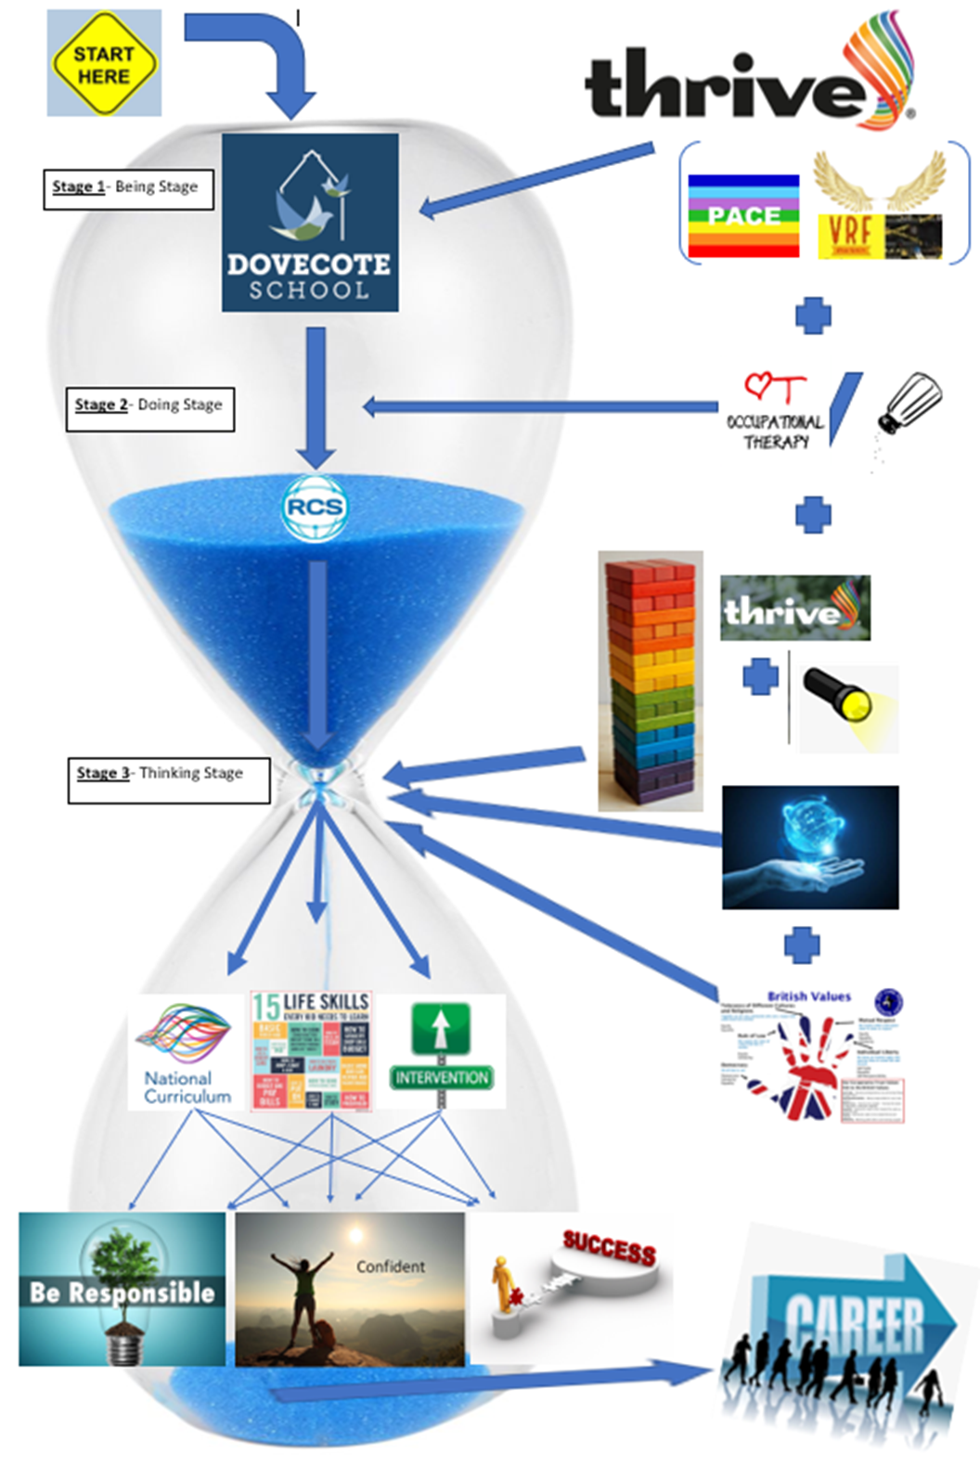

Appendix 2 - Curriculum Planning

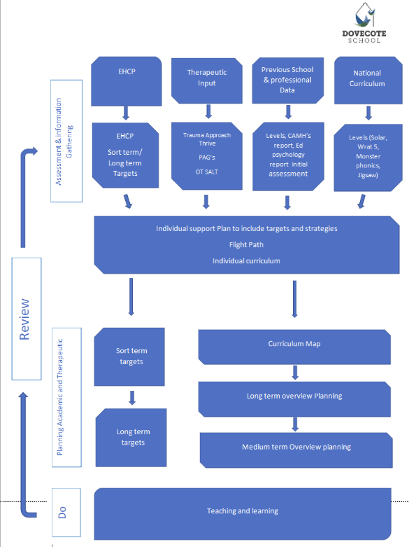

Appendix 3 - Curriculum Planning

