Curriculum Policy

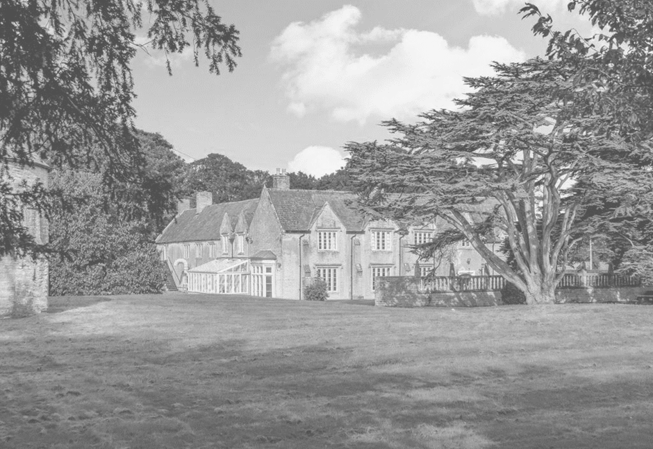

|  |  |  |
| --- | --- | --- |
| **Approved by:** | **Neil Gage** | **Date: 1st September 2025** |
| **Last reviewed on:** | **1st August 2025** | |
| **Next review due by:** | **1st August 2026** | |

**Contents:**

Statement of intent

1. Legal framework
2. Curriculum intent
3. Curriculum Implementation
4. Curriculum Content
5. Assessment
6. Monitoring and Review

**Statement of intent**

Dovecote School recognises the importance of offering a broad and balanced needs-led curriculum which underpins our shared school vision and prepares our students for adulthood.

Our needs-led curriculum is designed to develop:

* Social and communication skills
* Emotional literacy
* Physical wellbeing
* Cultural awareness including British Values
* Cognition and learning skills

Through our curriculum we meet the individual needs of our students by providing appropriate adaptations to enable all students to thrive. All students and their families at Dovecote have access to:

* an individualised and supportive transition process.
* an effective home – school communication strategy which ensures a shared understanding and implementation of the Thrive approach; intervention and therapy; and personalised academic pathways to promote holistic decision making.
* a wider team of multi-agency SEND support.
* an individualised and appropriate accreditation pathway.
* a robust Preparation for Adulthood programme.
* A nurturing environment which celebrates success in all its forms.

# Legal framework

This policy has due regard to all relevant legislation and statutory guidance including, but not limited to, the following:

* Children Act 2004
* Education Act 2004
* Equality Act 2010
* DfE (2015) ‘Special educational needs and disability code of practice: 0 to 25 years’
* DfE (2014) ‘The national curriculum in England’
* Keeping Children Safe in Education 2025
* Relationships Education, Relationships and Sex Education (RSE) and Health Education DfE 2019
* Respectful School Communities: Self Review and Signposting Tool
* Behaviour and Discipline in Schools
* Mental Health and Behaviour in Schools
* SMSC requirements for independent schools
* National Citizen Service guidance for schools
* Careers guidance and access for education and training providers 2023

This policy operates in conjunction with the following school documentation:

* Assessment and Examination Policy
* Careers Policy
* Equality, Equity, Diversity and Inclusion Policy
* PSHE & RSE (Relationships Sex and Health Education) Strategy
* Special Educational Needs and Disabilities (SEND) Policy
* SMSC strategy.
* Reading strategy

# Curriculum Intent

At Dovecote School, we deliver an exciting and innovative curriculum, specifically developed to meet the needs of students with SEN. The key aim of our curriculum is to prepare our students for adulthood. Through a positive and supportive framework, we help to overcome barriers to progress and enable our students to become:

* Responsible individuals - Who make productive contributions to democratic society and follow the rule of law.
* Confident learners - who can identify with themselves and lead safe, healthy, and fulfilling lives.
* Successful learners - who enjoy school, make great progress, and achieve a range of skills and accreditations which lead to further success as a young adult once they leave Dovecote.

# Curriculum Implementation

**Our needs led curriculum**

is delivered within a safe, nurturing environment. The physical environment is designed to enable our students to use the space in a way that supports their emotional regulation and provide psychological safety through a sense of containment. In addition, it provides opportunities to access both indoor and outdoor areas that develop student interests. The inclusion of gardens, a farm, forest school and Thrive pods builds skills which are both therapeutic and vocational. The therapeutic curriculum is delivered using the Thrive approach, through which staff are able to build safe relationships, promote positive mental health and support the development of student’s sense of well-being, self-awareness and self-esteem. The school Thrive approach and restorative Thrive sessions allows Dovecote to work to overcome barriers to social and emotional development, alongside work towards ‘right time’ experiences/ development. These supports bridging the gaps from earlier missed opportunities and the experience of children and young people in the ‘now’. Students have access to right time focussed work through group Thrive sessions, delivered by a Licenced Practitioner and, when required, also through individual Thrive interventions to support development. Dovecote therapeutic approach allows us to meet a child’s needs in the ‘here and now’ and to adapt our approach to support what can be a changing emotional landscape.

Dovecote Therapeutic approach delivers a graduated approach to engagement with learning, taking young peoples’ readiness to engage as an indicator of confidence to take risks in learning. The Thrive approach ensures we consider young people’s readiness to learn through the lens of potential interruptions in their social and emotional development so we can identify where young people might need support to develop resilience. The quality of relationships in school supports students’ engagement and attendance.

**Our academic curriculum**

is needs-led and is designed to be flexible so it can be accessed in line with a child’s readiness to learn as defined by their Thrive assessments and academic assessments which establishes individuals' levels of skills and knowledge. We are mindful of the different journeys our students have experienced within education. Our transition process, in-house speech and language therapists, occupational therapists, SEND team and staff trained in the Thrive approach enables us to undertake holistic assessments which enable us to provide an appropriate education, at an appropriate pace.

From the start of transition, we aim to build a feeling of being safe, special and one where we meet needs within our relationship to help children and young people to feel motivated to attend school. This is built through a focus on special interests, relationships encourage through playfulness, acceptance, curiosity and empathy. This includes environment familiarity so that they feel comfortable with school. Each student will develop confidence and security when they are ready. When students are demonstrating safety in relationships and the environment, we can begin to introduce learning opportunities to stretch their window of tolerance and build resilience in learning.

Being ready to learn involves initiation, engagement and doing in the range of activities and subjects on offer. Often ‘play’ can be a facilitator for this; whatever the age of the child or young person we refer to this as Phase 1. Hands on experience can enhance the learning process and during this period, children and young people will begin to demonstrate some understanding of their internal social and emotional landscape and their social interactions. As students adventure, we start to introduce and explore academic subject knowledge and interests.

Once students are ready to engage with an Academic curriculum (Phase 2), the requirement outlined in **Section F of their EHCP** will define the planning of their timetable, to ensure their cognition and learning needs, their social and emotional needs, their physical and sensory needs and their communication needs are all adequately met. Communication between parents/carers and Special Educational Needs coordinators (SENCO) will ensure a well-balanced and appropriate curriculum of reach child.

To ensure we offer an ambitious curriculum that has high expectations of our students, we promote a love for learning through a range of teaching styles, activities and targeted interventions, designed to meet the personalised needs of each student. The use of technology as both an adaptation and as a tool for life is embedded throughout the school.

Our personalised approach to learning throughout the school aims to ensure that our students leave with the necessary skills and knowledge to become independent functional adults. Regular cognitive, social and emotional assessments mean we can ensure that a child’s curriculum is both challenging and realistic – maximising their Post 16 options.

# Curriculum content

The Phase 2 (KS1, KS2 & KS3) academic curriculum is mapped to the 2014 Primary National Curriculum and 2014 National curriculum in England Key stages 3 and 4 framework. This ensures comprehensive coverage of the National Expectations. Humanities is delivered through Imaginative Learning Projects (topics), which provide a rich menu of exciting and motivating learning. We make creative links between all aspects of our students’ learning. Research shows us that our students engage more readily in learning, when they are encouraged to use their imagination and apply their learning to their interest and real-life experiences. Our academic curriculum provides lots of learning challenges that require students to solve problems, use creative skill and express their knowledge and understanding effectively across all their subjects. These essential skills are linked to activities that monitor ability, allow Dovecote to track student’s progress and identify their academic individual learning needs.

As students become more able to access longer phases of learning (Phase 2), the academic curriculum is delivered through a combination of class teachers, specialist teachers and instructors, who oversee the planning, assessment and implementation of lessons. This supports a successful transition between the Phase 2 into Phase 3 (Qualifications or KS4 traditional curriculum). The curriculum in phase 3 continues to be based on the national curriculum, with students accessing it by stage rather than chronological age.

At Phase 3 (KS4) Subjects are delivered through discrete lessons that meet Awarding bodies syllabus requirements. Students will be entered for Qualifications at appropriate levels according to needs and cognitive assessment data which indicates a student’s starting point. This may include Entry level awards (NCFE), Functional Skills (entry, Level 1 & Level 2) Awards, Certificates in BTECs (level 1 & Level 2), Arts awards (Intro, Bronze & Silver awards) and GCSEs/ IGCSE’s. These will be delivered as part of a 1-to-3-year programme. All students in Phase 3 (KS4) up to the age of 19 years old)) access a personal development programme that includes Life Skills, Careers, PSHE, RSE Group thrive, 1:1 thrive, SCLN, Study skills, Touch Typing and IDL interventions. Parental support with this process is fundamental to success.

As a school we do not offer a Key Stage 5 curriculum. However, as student may not be working at age and start their qualifications at an earlier stage, students will follow the Phase 3 curriculum which is aligned with the Key Stage 4 Dovecote framework to ensure continuity and consistency in their learning. For those joining Dovecote after completing Key Stage 4 elsewhere or not in education, a tailored two-year programme will address their individual needs as outlined in their EHCPs. This programme will focus on reinforcing core skills from the KS4 curriculum while offering personalised support through targeted therapies and interventions. Key components will include GCSE/functional skills (L2) in English, Maths, and individual options, life skills such as independent living, communication, and emotional regulation, and vocational opportunities such as work experience and enterprise projects to prepare students for adulthood. Regular progress reviews will ensure alignment with EHCP goals, supported by collaboration with families and external agencies to facilitate smooth transitions to post-18 pathways, including further education, supported work experience, or other bespoke options.

**Our Core Lower/Middle school taught curriculum**

**A child’s curriculum may also include the following dependent upon needs, interest and cognitive and Thrive assessment data.**

**Our Phase 3 (Accredited curriculum) offer**

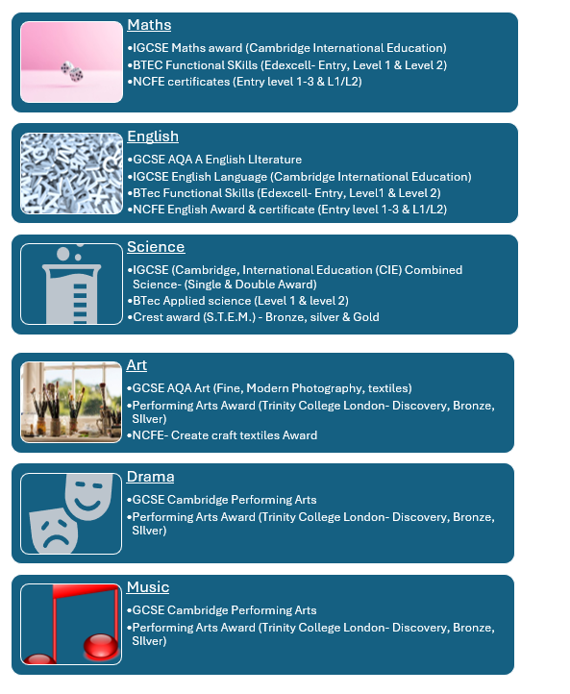



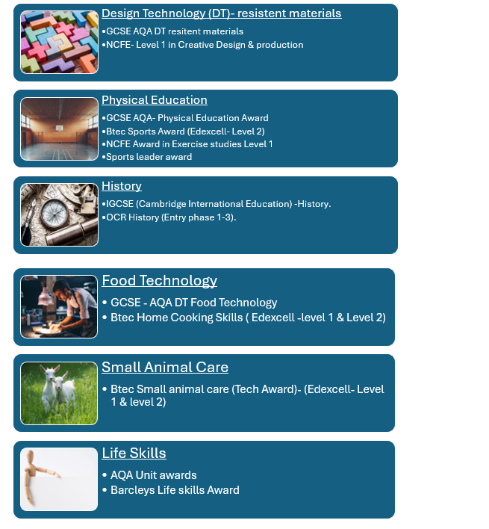

* Students may choose 2 options subjects in addition to English and Maths. There is the possibility of a third option for those whose data shows this would be appropriate.
* The number of option choices is depicted by the Needs met curriculum and associated hours linked to interventions listed in section F of the EHCP.
* Our SEND team will support the process of choosing options to maximise opportunities for fulfilling life goals and ambition as well as ensuring we meet the Needs set out in the EHCP (Section F). The number of option choices will be directly impacted by factors such as the young person's time remaining in school, Section F needs and engagement in core provision.
* All students access PSHCE/ RSE/ Preparation for Adulthood (life skills) and Careers education.
* Students also have the option to participate in the Duke of Edinburgh Award scheme and work experience.

**Reading for life**

As a school we have a clear reading strategy which aims to develop a whole school culture that nurtures a love of reading. Reading at Dovecote School is embedded within the fundamental structures of the school. Throughout their time at Dovecote reading will be celebrated and nurtured through explicit teaching and embedding throughout the curriculum and school environment.

Reading for pleasure provides an individual with cultural enrichment, companionship, and intellectual challenge. It is our goal as a school to provide an environment where the young people in our care can discover the simple joy of reading for themselves, sitting with a book or listening to a story told by a trusted adult without pressure, or demand.

Our comprehensive assessment process means that our SEND team are able to identify gaps in learning and ensure rapid whole group or individual intervention takes place to enable a child to make accelerated progress in those targeted areas.

**PHSE / RSE / Careers**

**PSHE/RSE** and careers is at the core of Dovecote’s explicit and implicit curriculum and a vital strand in our Preparation for Adulthood programme. Our explicit PSHE/RSE curriculum is implemented through schemes and resources from Jigsaw and the PSHE association. In conjunction with Thrive sessions these can be taught independently or as a part of an intervention-based delivery dependent upon individual need. At Dovecote we also recognise the value of having a responsive PSHE/RSE program which responds to trending data from our analysis within our safeguarding and behaviour meetings.

**Careers guidance and the World of Work** will be delivered through explicit lessons meeting the Gatsby Benchmarks and in line with the DfE Careers guidance and access for education and training providers. More information about our careers programme can be found in our Careers Policy.

Independent Advice & Guidance is provided by a SEND specialist Level 7 qualified advisor. Students in years 9-11 receive one session per year, this includes Students in year 12/13 if they are KS4+) receive 2 across the two years. This guidance then contributes to their transition review planning into Post 16 provision run by the SENCO. This includes careers plan which includes the 1:1 information, recommendation for local colleges that offer the relevant courses and action plan for school/ parents and pupils to follow to achieve their goals.

**Spiritual, Moral, Social, and Cultural Development (SMSC).**

SMSC is integrated and mapped throughout the Dovecote Curriculum. SMSC will be particularly evident in the PSHE curriculum but is woven throughout our explicit and implicit curriculum. More information about our careers programme can be found in our SMSC strategy.

# Assessment

At Dovecote we assess students’ skills and knowledge in core areas of cognition, communication, and emotional literacy, using standardised assessments. These include GL English (PTE), GL Maths (PTM), GL Science (PTS), and upon entry to the school GL CAT4 (independent) test. PTE, PTM, PTS are run twice a year (October & June). In addition, we test using the RAN/ RAS, Phab 2, BVPS, and IDL Testing yearly. Within units/ curriculum teaching, teachers are using pre post testing and assessing Skills/ Knowledge and understanding against the national curriculums (Ks1-4) with mini tests, quizzes and formative assessment tasks. In Phase 3, Mock exams with past papers for qualifications indicators are used post units both as means to preparation but to recall KSU within the subject.

Internal assessing and monitoring take place 3 times a year for those who can access it. Where necessary further specialist screening will take place to inform teaching and intervention planning. Pathway planning is informed by these standardised assessments, alongside formative and summative assessment of the skills, knowledge and understanding developed through delivery of the national curriculum.

At KS4 the level at which students take different qualifications is based upon the holistic quantitative and qualitative assessment data available for that student. Students may swap course level, dependent upon need, engagement or ability to access and recall knowledge in the testing styles of the award.

Student progress, attainment and engagement is fed back and discussed with parents through reports (2 progress reports (Dec & April) and a full end of year report (July), tutors, Thrive family liaisons/ communications and annual reviews.

Additional assessments required for access arrangements is completed by an appropriate assessor in line with JCQ guidelines.

Standardised assessments include:

* York
* Youngs
* Read Write fresh start
* IDL
* Dyslexia portfolio
* Lucid exact
* BPVS
* TALC
* RAN/RAS
* GL Progress Test Eng /Math/Science
* Thrive

For further information please see our assessment and examinations policy.

**6. Monitoring and review**

Advisory Board and SLG in conjunction with Subject Leads monitor the standards of curriculum delivery through robust quality assurance systems which include.

* Learning walks/observations
* Work and planning scrutiny
* Progress data analysis
* Curriculum deep dives
* Sharing good practice sessions

The Policy will be reviewed again in July 2026 by Curriculum team

**Written By Mark Thompson September 2025**