Building Positive Relationships (Behaviour) Policy
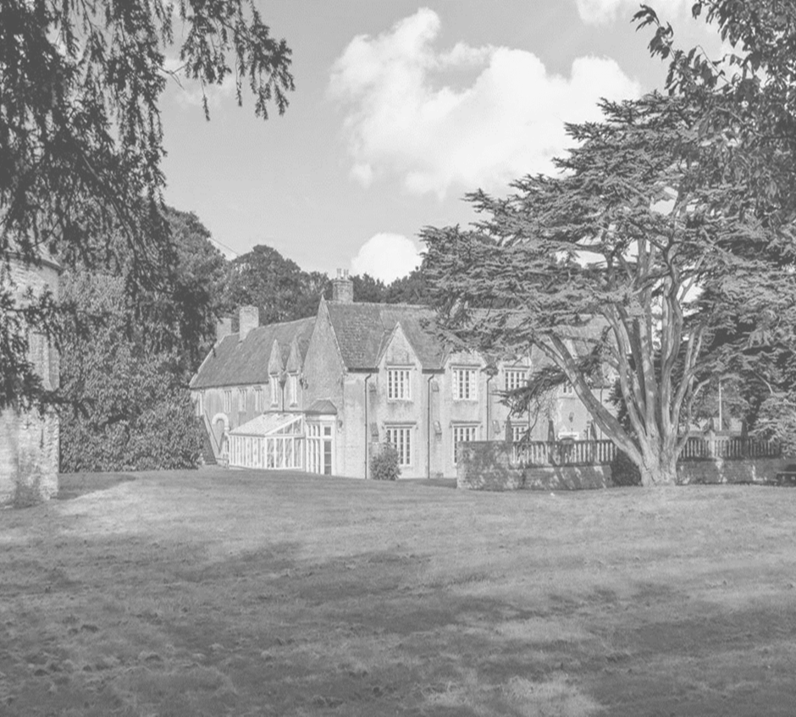
Date policy last reviewed: | 27/01/2023

Signed by:
Neil Gage | Headteacher | Date: | 27/01/2023
Jason Goddard | CEO | Date: | 27/01/2023

Contents:
Statement of intent
- Legal framework
- Roles and responsibilities
- Definitions
- Students with Autism diagnoses- behaviour factors:
- Staff induction, development and support
- Managing behaviour
- Prevention strategies, interventions, and sanctions for unacceptable behaviour
- Sexual abuse and discrimination
- Smoking and controlled substances
- Prohibited items, searching students and confiscation
- Effective classroom management
- Behaviour outside of school premises
- Data collection and behaviour evaluation
- Monitoring and review

Statement of intent

Dovecote School aims to develop every young person, supporting them to be Responsible, Confident and Successful individuals ready for the wider world. The school systems are foremost developed around building Social and Emotional wellbeing, through the process of developing effective strategies to be resilient in a career/education and life beyond Dovecote school. The Initial curriculum focuses on helping students settle, feel Safe, Special and having needs met (Being Stage) and then co adventuring along staff (Doing) to explore and experiment with engagement in play-based learning. In this phase staff utilise Thrive and Therapeutic parenting techniques to help with Social and emotional progress. As students move into the Thinking stage, Dovecote supports further development of higher level cognition of Social, Emotional, Moral and cultural values; promoting Academic curriculums/awards and achievements, Personal curriculum/awards and achievements, the development of Independent Life skills and the promotion of British Values (Mutual respect, Independent Liberty, Rule of Law, Democracy and Tolerance for culture and religions). Staff deploy therapeutic (Thrive) approaches which form the foundation of the behaviour practices and policy below.
To facilitate teaching and learning, socially acceptable behaviour must be demonstrated in all aspects of school life. The school is therefore committed to:
- Promoting desired social and school behaviours.
- Promoting positive sense of self and growth of self-esteem, confidence, and self-discipline
- Promoting recognition of and understanding for a need for authority, and positive relationships based on mutual respect.
- Ensuring equality and fair treatment for all.
- Promoting a culture of praise and encouragement, using individual strategies, in which all students can achieve.
- Providing a safe and secure environment. This includes free from disruption, violence, discrimination, bullying and any form of harassment.
- Encouraging positive relationships with parents & adults around them.
- Developing positive and safe relationships with students.
- Building a shared approach which involves students in the implementation of the school’s policy and associated procedures.
- All undesirable/discharge behaviours are viewed as communication of unmet need and under-developed skill in expressing big feelings.

1: Legal framework
This policy has due regard to all relevant legislation and statutory guidance including, but not limited to, the following:
- Education Act 1996
- Education Act 2002
- Equality Act 2010
- Education and Inspections Act 2006
- Health Act 2006
- Voyeurism (Offences) Act 2019
- The School Information (England) Regulations 2008
- DfE (2022) ‘Behaviour in schools: advice for headteachers and school staff’
- DfE (2023) ‘Keeping children safe in education 2023’.
- DfE (2021) ‘Sexual violence and sexual harassment between children in schools and colleges’
- DfE (2018) ‘Mental health and behaviour in schools’
- DfE (2015) ‘Special educational needs and disability code of practice: 0 to 25 years’
- DfE (2013) ‘Use of reasonable force’
- DfE (2022) ‘Searching, screening and confiscation: advice for schools’.
This policy operates in conjunction with the following school policies:
- Student Code of Conduct
- Complaints Procedures Policy
- Special Educational Needs and Disabilities (SEND) Policy
- Suspension and Exclusion Policy
- Physical Intervention Policy
- Child-on-child Abuse Policy
- Child Protection and Safeguarding Policy
- Anti-bullying Policy

2: Roles and responsibilities
The CEO will have overall responsibility for:
- Making a statement of behaviour principles and providing guidance for the headteacher on promoting positive engagement and desirable behaviours.
- Ensuring that this policy, as written, does not discriminate on any grounds, including, but not limited to, age, disability, gender reassignment, gender identity, marriage and civil partnership, race, religion or belief, sex and sexual orientation.
- Promoting a whole-school culture where calm, dignity and structure encompass every space and activity.
- Handling complaints regarding this policy, as outlined in the school’s Complaints Procedures Policy.
- Ensuring this policy is published on the school website.
The headteacher will be responsible for:
- The monitoring and implementation of this policy and of the behaviour procedures at the school. This includes monitoring the policy’s effectiveness in addressing any SEMH-related drivers of poor behaviour.
- Acting in accordance with the statement of behaviour principles made by the CEO and advisory board and having any regard to guidance provided by the advisory board on promoting desirable behaviour.
- Establishing high level of ambition of students’ conduct and behaviour and implementing measures to achieve this.
- Determining the school non-negotiables and any outcomes for compromising these non-negotiables.
- The day-to-day implementation of this policy.
- Publicising this policy in writing to staff, parents and students at least once a year.
- Reporting to the advisory board on the implementation of this policy, including its effectiveness in addressing any SEMH-related issues that could be driving disruptive behaviour.
The Deputy Head teacher, SENCo and Thrive & Family Liaison leads will be responsible for:
- Overseeing the whole-school approach to mental health, including how this is reflected in this policy, how staff are supported with managing students with SEMH-related behavioural difficulties, and how the school engages students and parents with regards to the behaviour of students with SEMH difficulties.
- Supporting positive inclusion and engagement in line with the SEMH Policy.

The SENCO will be responsible for:
- Collaborating with the advisory board, headteacher and the senior mental health lead, as part of the SLG, to determine the strategic development of behaviour and SEMH policies and provisions in the school.
- Undertaking day-to-day responsibilities for the successful operation of the behaviour and SEMH policies to support students with SEND, in line with the school’s Special Educational Needs and Disabilities (SEND) Policy.
- Supporting teachers in the further assessment of a student’s strengths and areas for improvement and advising on the effective implementation of support.
Teaching staff will be responsible for:
- Planning and reviewing support for students with behavioural difficulties in collaboration with parents, the SENCO and, where appropriate, the students themselves.
- Aiming to engage all students in the full curriculum, whatever their prior attainment.
- Planning lessons to address potential areas of difficulty to put strategies in place to break down barriers to every student achieving their full potential, and that every student with behavioural difficulties will be able to study the full national curriculum.
- Teaching and modelling positive engagement, supportive, safe and respectful relationships and healthy habits.
- Being responsible and accountable for the progress and development of the students in their class.
- Enforcing non-negotiables in line with the students social and emotional understanding and carrying out restorative and reparative work to develop this understanding.
All members of staff, including teaching and support staff, and volunteers will be responsible for:
- Adhering to this policy and applying it consistently and fairly.
- Supporting students in adhering to this policy.
- Promoting a supportive and high-quality learning environment.
- Modelling desirable behaviours which enables access to the full social and academic curriculum.
- Setting high expectations for every student.
- Being aware of the needs, outcomes sought, and support provided to any students with specific behavioural needs.

- Keeping the relevant members of the management team (SLG) up to date with any changes in behaviour. The relevant figures of authority (SLG) include:
  - Headteacher.
  - Deputy Head Teacher.
  - SENCO.
  - Thrive and Family Liaison Lead.
  - Middle & lower school Lead.
  - Upper school lead.
- Following an authorised (by the headteacher) discussion and implementing agreed responses to behaviour outside of school for students who display non-negotiable behaviours that affect the school or carry over to the school environment.
Students will be responsible for:
- Developing the skills to take ownership of their own behaviour; including ways to be outside of school and recognising when others are struggling and feeling safe to report this.
- Reporting any undesirable behaviour to a member of staff.
- Developing (with Support) strategies to cope with anxiety to access and enter public arenas/ life outside of school.
Parents will be responsible for:
- Supporting their child in adhering to the non-negotiables (Society’s and school) and working in partnership with school to develop understanding of this at home.
- Informing the school of any changes in circumstances which may affect their child’s behaviour, engagement and mental health.
- Communicate effectively with the school their practices used at home.
3: Definitions
For the purposes of this policy, the school will define “serious non-negotiable/ undesirable behaviours” as.
‘Any behaviour which may cause harm to oneself or others, damage the reputation of the school within the wider community, and/or any illegal behaviour.’
This will include, but is not limited to, the following:
Anti-Social Behaviours.
- Discrimination – not giving equal respect to an individual, based on; age, disability, gender identity, marriage and civil partnership, pregnancy and maternity, race, religion or belief, sex, and sexual orientation.
- Harassment – behaviour towards others which is unwanted, offensive and affects the dignity of the individual or group of individuals.
- Vexatious behaviour – deliberately acting in a manner as to cause annoyance or irritation to other students when not part of normal presentations.
- Bullying – a type of harassment which involves personal abuse or persistent actions which humiliate, intimidate, frighten, or demean the individual being bullied.
- Cyberbullying – the use of electronic communication to bully a person, typically by sending messages of an intimidating or threatening nature.
Risk Taking behaviours- behaviours that met an individual need/ that create a sensation or feeling inside them that they have control of. For example: - (not exhaustive)
    - Physical assault- including biting/ spitting.
    - Criminal damage
    - Intimidation
    - Absconding/ Truancy and running away from school.
    - Substance abuse
    - Harm to animals
    - Possession of legal or illegal drugs, alcohol, or tobacco
    - Possession of banned items
    - Refusing to comply with disciplinary sanctions.
    - Theft
    - Verbal abuse, including swearing, racist remarks and threatening language.
    - Fighting and aggression
    - Climbing at height
    - Persistent avoidance of requests or disruptive behaviour
    - Extreme behaviour, such as violence and serious vandalism
    - Any behaviour that threatens safety or presents a danger (e.g., weapons, Arson)
    - Any behaviour that seriously inhibits the learning of students
    - Any behaviour that requires the immediate attention of a staff member
Non-Negotiable behaviours- these are undesirable behaviours that are unacceptable within society or school.

Anxiety induced behaviours- often triggered by social interactions, interception (internal feelings), emotional release or by environmental triggers. These behaviours can be viewed as flight/ fight/ freeze responses. They include, but are not limited to, the following:
‘Fight’ response/anxiety behaviours: -
- Swearing
- Verbally abusive language including sexualised innuendos.
- Low-level disruption / talking that disrupts the class.
- Rudeness
- Disruption on public transport
- Graffiti
- Use of mobile phones without permission
‘Freeze’ response/anxiety behaviours: -
- Failure to complete classwork
- Refusing to complete homework, incomplete homework, or arriving at school without homework
‘Flight’ response/anxiety Behaviours:-
- Lateness/refusing a lesson/walking out or away- climbing gates fences or windows.
“Low-level anxiety behaviour” may be escalated to “serious non-negotiable/unacceptable behaviour”, depending on the level of risk of the behaviour.

4: Students with Autism diagnoses- behaviour factors:
At Dovecote school, we recognise that Autistic students or those with ACE’s and Trauma can find situations & environments overwhelming. Factors include sensory input (things you see, hear, feel, smell or taste), demands placed upon them e.g. being asked to do things that cause stress or distress, or through the interception (internal feelings) that are not always verbalised or nameable. These can Trigger an autistic person to become overwhelmed.
When an autistic person becomes overwhelmed and unable to use or benefit from their coping strategies, they might have a ‘meltdown’ or ‘shutdown’.
As a school, we recognise that a meltdown isn’t a tantrum. A tantrum is something that a child can control, and tantrums often happen because a child wants something. A meltdown or shutdown isn’t something an autistic person can control, and it’s caused by being overwhelmed. During a meltdown, an autistic person might try to make themselves feel less overwhelmed. This can include doing things like:
- trying to get away from people (flight) – for example by running away or hiding.
- trying to get people away from them (fight responses) – for example by shouting, screaming, hitting, or acting aggressively.
During a shutdown, an autistic person might try to block everything out – for example by not responding to anything or anyone around them.

Undesirable behaviours: -
Like everyone, autistic students can display challenging behaviour if they’re in the wrong environment. While it can be challenging for the people around them, this behaviour is often a result of distress or frustration, particularly if an autistic person experiences barriers to communication (internal an/or external).
Behaviour that challenges others is usually a way for someone to get their needs met when they don’t have any other way to do so. It’s not ‘bad’ behaviour or intended to cause harm. This kind of behaviour is most common in children, or people who find it hard or don’t yet have the skill to communicate their needs – for example, people with a learning disability.
Behaviour that challenges can also be caused by:
- trying to meet sensory needs – for example, wanting to do something because it feels nice, like rubbing soaps and creams all over themselves and the walls.
- wanting something – for example, being hungry or wanting to play with a toy.
- needing assistance or attention – for example, because they're bored or want help with a project at school.
- trying to escape an environment or the people around them, but doing so in a way that can be dangerous or harmful, such as running into the road.
Behaviour that people can find challenging includes:
- being destructive – eg: breaking things in the environment
- being disruptive – eg: making noise in class or throwing things
- self-harm
- aggression

Getting the right environment
Environment is important to quality of life for all students and at times more challenging when supporting autistic people. As a school we aim to adapt (change) and improve the environment to make it as comfortable and supportive as possible for your child.
The social model of disability is a way of looking at the world that treats the difficulties people with disabilities have as being caused by barriers in society, rather than just the disabilities themselves. These barriers can be physical – for example, buildings not having accessible toilets. Barriers can also be caused by people’s attitudes – for example, many people will assume someone is lying because they don’t make eye contact while talking.
The social model of disability can be a helpful way of considering the difficulties a student faces, and how to adapt their environment so it works for them.
Autism is covered by the Equality Act (2010), which means that schools and employers are required to make “reasonable adjustments” to ensure autistic people are comfortable in their environment and able to learn or work.
Common changes we have made and can offer within the school environment that can help include:
- sensory changes – for example, being given a quiet space to work, being able to use sensory toys like fidget spinners, or enabling expression of other sensory needs, E.G; making noise when working, to support engagement.
- communication changes – focus on using email or apps to communicate, using very clear language, allowing additional time to ask questions, or using visual communication such as photos or pictures as well as written words.
- routine – keeping to a regular routine and giving warning of any changes as far in advance as possible.
As a school, we view undesirable behaviours as communication of an unmet need. Reasonable and proportionate actions will be used (individually) where a student’s behaviour falls below the standard that is expected (e.g. non-negotiable school or social rules). The school acknowledges that behaviours can be the result of; educational needs, mental health issues, anxiety, or other needs or vulnerabilities that are unmet. As a school we aim to address these needs via an individualised graduated response.
To help reduce the likelihood of ongoing behavioural issues related to social, emotional or mental health (SEMH), the school aim to create a safe and calm environment in which positive mental health and wellbeing are promoted and students are supported to develop the skills to develop resilience for learning and life. The school aims to develop confident young people through the promotion of resilience as part of a whole-school approach using the following methods:
- Culture, ethos and environment – the health and wellbeing of students and staff is promoted through the informal curriculum, including daily and leadership practices, policies, values and attitudes that we use and includes the structure of the social and physical environment.
- Teaching – the curriculum is used to develop students’ knowledge about health and wellbeing, alongside intervention work undertaken by our range of therapeutic practitioners (SALT, OT, Thrive, Play Therapy)
- Community engagement – the school proactively engages with parents, outside agencies and the wider community to promote consistent support for students’ health and wellbeing.
All staff are made aware of the impacts of adverse childhood experiences, including abuse, neglect, multiple and unsuccessful school placements. Where vulnerable students or groups are identified, provision will be made to support and promote their positive mental health. The school’s Social, Emotional and Mental Health (SEMH) Policy outlines the specific procedures that will be used to assess these students for any SEMH-related difficulties that could affect their behaviour.

5: Staff induction, development, and support
All new staff will be inducted clearly into the school’s ethos and culture to ensure everyone understands the roles and responsibilities, in order to feel empowered to support students to develop in the school community. Staff are provided with bespoke training, (bespoke), on the needs of students at the school to enable behaviour to be managed consistently. Dovecote school Uses the Thrive Approach, CPI and Trauma informed approach to develop and deepen the therapeutic understanding of staff. This will be extended in response to specific needs and challenging needs of the student.
The Senior Leadership Group (SLG) will consider any appropriate training which is required for staff to meet their duties and functions in accordance with this policy, including on understanding matters which may affect a student’s behaviour, e.g., SEND and mental health needs.
All members of staff have responsibilities for leading behaviour or supporting student wellbeing. They will be supported to undertake any relevant training or qualifications (e.g. Thrive induction training, CPI training, Autism induction training and Trauma informed training).
The SLG and the headteacher will review staff training needs annually, and in response to any serious or persistent issues, disrupting the running of the school.
Staff receive induction training to give a foundation of learning in preparation for working alongside students which is then built upon over the course of there working career with Dovecote, developing understanding, knowledge and skills further. Weekly CPD and regular re-visit to key performance indicators are delivered across the year. Please review the Appendices which explains to Parents, Carers and Linked Professionals, the wide range of Thrive practice that underpins the school’s key Therapeutic approaches.

6: Managing behaviours
Instances of behaviour which sit outside of school non-negotiable rules will be taken seriously and dealt with immediately. Staff will respond promptly, predictably and with confidence to maintain a calm, safe learning environment. Staff are trained to and will use, CPI approach to de-escalate, respond and react to serious, unsafe situations. Staff will de-brief from any such incident and consider ways to support a student to develop skills to regulate and manage.
Dovecote school keep a record of all reported incidents (CPOMS software) to help identify students whose behaviour is indicating ongoing difficulties with regulation, possible mental health or safeguarding issues. All staff will be alerted to changes in a student’s behaviour that could indicate they need help or protection.
Support, such as focused discussions with students, a phone call with parents, and inquiries into circumstances outside of school by the DSL, will be undertaken in response to low level and high level anxiety induced behaviours. After any occurrence of Non desirable (risk taking/ anxiety induced, non-negotiable/or anti-social behaviours) the following responses will be considered, with staff using their professional judgement and experience to determine what is appropriate and reasonable:
- Review of Thrive strategies used.
- Add/ Update the one page profiles, risk assessments and provision maps.
- Dissemination to all staff new strategies/ actions need for future events (debrief/ morning briefing).
- Undertake a Thrive re-assessment.
- Plan and deliver if relevant any intervention work (PSHE/ SALT/ OT/ Play Therapy)
- Employ SLG optional actions if relevant (e.g.- timetable change, use of external education services, bans, home/ professionals meeting etc...) including use of SALT/ OT Ed Phycologist to review strategies to support.
- Make use of the Thrive Approach ‘Shining the Light’ to support work around how to regulate effectively.
- Setting a task, that reviews/ reflect/ reframes their behaviour.
- Removal of privileges

Where a student’s presentations are causing significant disruption or is deemed serious enough by a SLG member, the following procedures will be followed:
- In the headteacher’s absence, the most senior member of SLG will lead investigation of the incident and will decide whether it constitutes high level response.
- The SLG lead will record the actions/ response against the CPOM’s incident log.
- Where deemed necessary, e.g. after other behavioural strategies have been attempted or the behaviour is so extreme as to warrant immediate removal, the student will be removed from school. A plan will be designed for future intervention work needed.

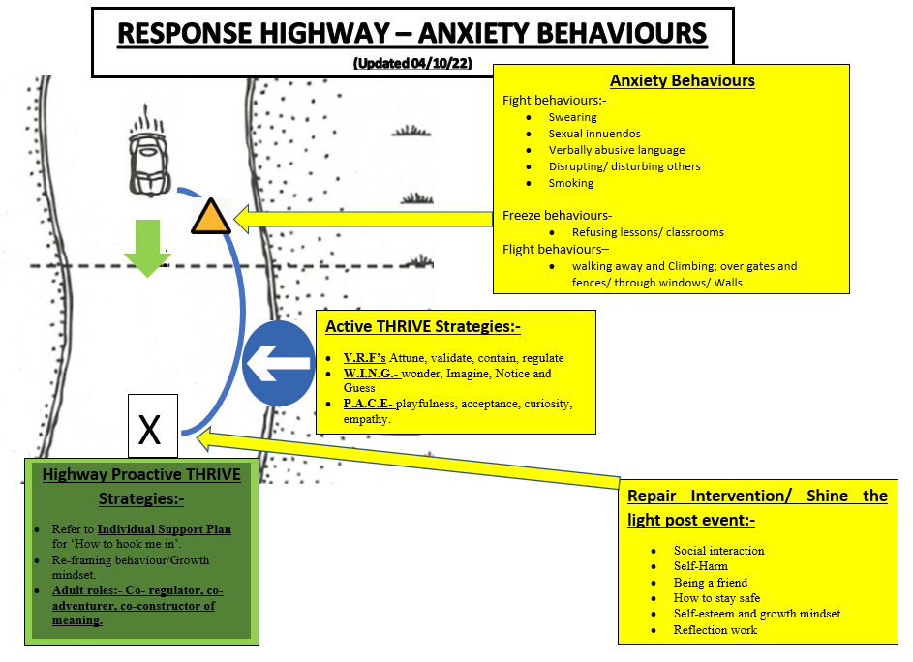
(Adapted from Developmental Parenting Highway – Ref: Jean Ilsley-Clarke)

Following repeated incidents of non-negotiable undesirable behaviour, the following actions will be implemented:
- The headteacher will consider whether the student should be suspended, in line with the school’s Exclusion Policy, and will determine the length of the suspension.
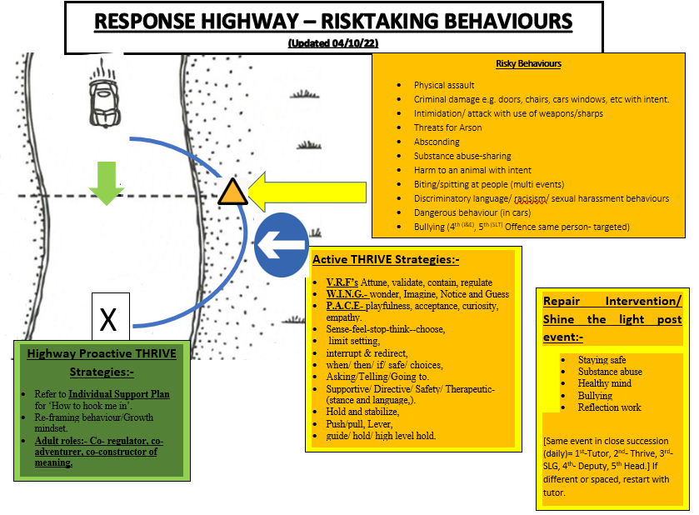

Following further incidents, the following actions will be implemented:
- Where non-desirable behaviours continue or escalate further or are of such severity the student may be moved onto Steps 1 (action plan with home/ linked professionals and SLG).
- Step 2 (meeting with SEN team and home raising serious concerns).
- Step 3 calling of an E.A.R (emergency annual review).

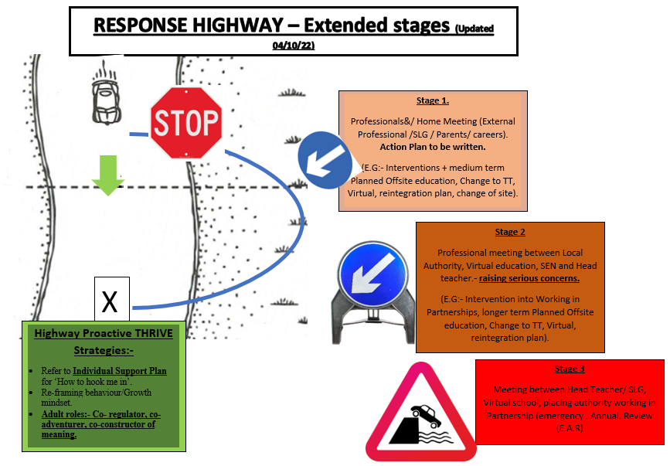
The headteacher will consider whether a permanent exclusion is necessary, in line with the school’s Suspension and Exclusion Policy, alongside alternative options such as a managed move or off-site direction.

For discipline to be lawful, the school will ensure that:
- The decision for this line of action is made by a paid member of school staff, is a member of staff authorised to do so by the headteacher (SLG).
- The decision for this course of action is made on the school premises or whilst the student is under the charge of a member of staff, such as during an educational trip or visit.
- The decision for this course of action is reasonable and will not discriminate on any grounds, e.g., equality, SEND or human rights.
The school will ensure that all actions are reasonable in all circumstances, and will consider the student’s age, religious requirements, SEMH needs, any SEND, and any other contributing factors, e.g., bullying, safeguarding or home life issues.

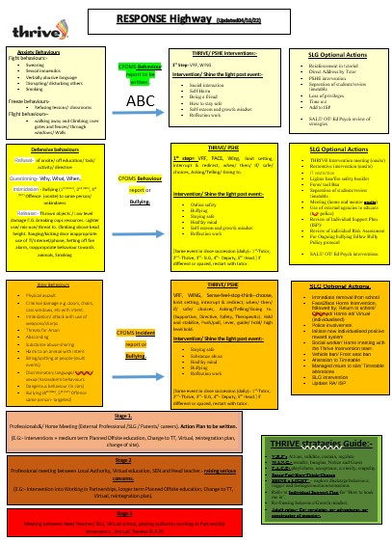

Please see appendix for full scale version.

7: Prevention strategies, intervention, and responses for undesirable behaviours.
This section outlines the school’s strategies for preventing undesirable behaviour and initial interventions, minimising the severity of incidents. The theory behind these Techniques are outlined in Appendix A. These approaches are used in various orders by staff, who observe and then assess the young person. To inform newer staff a one page profile is kept live outlining the young person’s needs.
Initial interventions
A range of initial intervention strategies are used to help students manage their behaviour and reduce the likelihood of more severe actions. These are based upon the Thrive practices all staff receive training on and are reflected in the Nurture Structure Developmental Parenting Highway. (Please see The Appendices). Support will consider the student’s specific needs and may be delivered, in small groups or in one-to-one activities. A system will be in place to ensure relevant members of the SLG and staff are aware of any student that are:
- Persistently presenting non-negotiable, anti-social or risk taking behaviours.
- Not improving their behaviour following low-level intervention work
- Displaying a sudden change in presentation from previous patterns of behaviour
Examples of initial interventions to address undesirable behaviour will include, but are not limited to, the following:
- Frequently engaging
- Communication with parents, including home visits/ teams calls where necessary.
- Providing mentoring and coaching
- Individual support plans and Risk assessments
- PSHE interventions work
- Thrive Intervention
- Individualisation of education curriculums
- SALT/ OT/ Ed Psych interventions & strategies, where applicable
- Engagement with local partners and agencies

A multi-agency assessment, such an early help assessment, that goes beyond a student’s education will be considered where serious concerns about a student’s behaviour exist.

Behaviour curriculum
Positive behaviour will be modelled and taught to all students as part of the whole school behaviour curriculum, in order to enable them to understand what behaviour is expected and encouraged and what is undesirable. Positive reinforcement will be used by staff where expectations are met to acknowledge positive behaviour and encourage repetition. The behaviour curriculum will focus on defining positive behaviour and making it clear what this looks like, including the key habits and routines required by the school, e.g. respect, compassion, empathy, etc.....
Routine will be used to teach and reinforce the expected behaviours of all students. Appropriate and reasonable adjustments to routines for students with additional needs, e.g. SEND, will be made. Consistent and clear language will be used when acknowledging positive behaviour and addressing undesirable behaviour.
Students will be supported to understand the negotiable and non-negotiable rules that we hold. This system allows student to express, reason and own negotiable rules.
Positive teacher-student relationships
Positive teacher-student relationships are key to combatting undesirable behaviour. The school will focus heavily on building positive relationships based on predictability, fairness and trust to allow both students and teachers to understand one another and create a strong foundation from which behavioural change can take place.
Preventative measures for students with SEN
Behaviour will always be considered in relation to a student’s SEND. As a school with a high proportion of Autistic students, much training and understanding has been gained by staff. We understand that the SEND has contributed to their behaviour, and that behaviour is a form of communication. The school will consider whether it is appropriate and lawful to implement actions to support the student.
Where a student is identified as having SEND, the graduated approach will be used to assess, plan, deliver and review the impact of support being provided.
The school will aim to anticipate likely triggers of undesirable behaviour and put in place support to prevent these, taking into account the specific circumstances and requirements of the student concerned. Measures the school will implement where appropriate include, but are not limited to, the following:
- Short, planned movement breaks for a student whose SEND means they find it difficult to sit still for long
- Ensuring a student with visual or hearing impairment is seated in sight of the teacher
- Adjusting uniform requirements for a student with sensory issues or relevant medical condition
- Training for staff in understanding autism and other conditions
De-escalation strategies
Where negative behaviour is present, staff members will implement de-escalation strategies to diffuse the situation. This will include:
- V.R.F’s- attune, validate, contain, regulate
- W.I.N.G- wonder, imagine, notice, guess
- P.A.C.E- playfulness, acceptance, curiosity, empathy
- Sense-Feel-Stop-Think-Choose
- Shine the light
- Reframing behaviour
- Choice of relevant adult roles (co-regulator/ co-adventure/ co-constructor)

Staff will use (not exhaustive) the following techniques when applying the above strategies;
- Appearing calm and using a modulated, low or mirrored tone of voice
- Using simple, direct language.
- Avoiding being defensive, e.g. if comments or insults are directed at the staff member.
- Providing adequate personal space and not blocking a student’s escape route.
- Showing open, accepting body language, e.g. not standing with their arms crossed.
- Reassuring the student and creating an outcome goal.
- Identifying any points of agreement to build a rapport.
- Rephrasing requests made up of negative words with positive phrases, e.g. “if you don’t return to your seat, I won’t help you with your work” becomes “ when you return to your seat, I can help you with your work”.
Physical intervention
In line with the school’s Physical Intervention Policy, all staff are trained in the CPI techniques and have the legal right to use reasonable force to prevent students from committing an offence, injuring themselves or others, or damaging school property, and to maintain good order and discipline in the classroom.
Physical restraint will only be used as a last resort and is classed as high-level intervention. Staff will also use lower-level intervention techniques like body blocks, guides and low/ medium level holds/ guides where necessary. Staff members will use their professional judgement of the incident to decide whether physical intervention is necessary. The situations in which physical intervention may be appropriate, are detailed in the Physical Intervention Policy.
Wherever possible, staff will ensure that a second member of staff is present to witness the physical intervention used or support its delivery. After an instance of physical intervention, the student will be supported to regulate and calm in a safe place or with safe person. Student’s parent will be contacted to make them aware. In serious cases parents may be asked to collect the student and take them home for the rest of the day.
Violent or threatening behaviour will not be tolerated by the school and may result in a fixed-term exclusion in the first instance. It is at the discretion of the headteacher as to what behaviour constitutes for an exclusion, in line with the Exclusion Policy.
When using reasonable force in response to risks presented by incidents involving students with SEND or medical conditions, staff will recognise and consider the vulnerability of these groups.
Removal from the classroom
The school may decide to remove students from a classroom/ change student timetable for a limited period, at the instruction of a SLG member of staff.
The student will be moved room to a new one that is:
- In an appropriate area of the school
- Stocked with appropriate resources.
- Suitable to learn and refocus.
- Supervised by trained members of staff.
The school will only remove students from a class where necessary and for the following reasons:
- To maintain the safety of all students and restore stability following an unreasonably high level of disruption.
- To enable disruptive students to be taken to a place where education can continue in a managed environment.
- To allow the student to regain calm in a safe space.
The school will ensure that students’ health and safety is not compromised during their time away from the classroom, and that any additional requirements, such as SEND needs, are met.
The amount of time that a student spends removed from the classroom will be up to the school to decide. This could be for more than one school day. The school will ensure that the student is not removed from the classroom any longer than necessary.
The headteacher will establish a clear process for the reintegration of a student who has been removed from a class when it is deemed appropriate and safe for them to return. Consideration will be given to what support is needed to help the student return and meet the expected standards of behaviour. Reintegration meetings will be held between the school, student and their parents, and other agencies if relevant, where necessary.

Detentions
The school do not use detentions as part of any actional response with students. Cause and effect discussion/ intervention or intervention strategies will be used to reinforce expectations as part of a therapeutic approach.
8: Sexual abuse and discrimination
The school will prohibit all forms of sexual abuse and discrimination, including sexual harassment, gender-based bullying and sexual violence. The school’s procedures for handling peer-on-peer sexual abuse and discrimination are detailed in the Child-on-child Abuse Policy.
The school will respond promptly and appropriately to any sexual harassment complaints in line with the Child Protection and Safeguarding Policy; appropriate steps will be taken to stop the harassment and prevent any reoccurrence. Discipline for incidents of sexual harassment will be determined based on the nature of the case, the ages of those involved and any previous related incidents.

9: Smoking and controlled substances
The school will follow the procedures outlined in its Smoke-free Policy and Student Drug and Alcohol Policy when managing behaviour in regard to smoking and nicotine products, legal and illegal drugs, and alcohol.
In accordance with the Health Act 2006, the school is a smoke-free environment. Parents, visitors, staff and students will be instructed not to smoke on school grounds. Students will not be permitted to bring smoking materials or nicotine products to school.
The school will have a zero-tolerance policy on illegal drugs, legal highs and other controlled substances. Where incidents with students related to controlled substances occur, the school will follow the procedures outlined in the Student Drug and Alcohol Policy and Child Protection and Safeguarding Policy.

10: Prohibited items, searching students and confiscation
Headteachers and staff authorised by them will have a statutory power to search students or their possessions, without consent, where they have reasonable grounds for suspecting that the student may have a prohibited item. Authorised members of staff will be permitted to use reasonable force when conducting a search without consent for the prohibited items listed below, in line with the school’s Physical Intervention Policy.

The prohibited items where reasonable force may be used are:
- Knives and weapons.
- Alcohol.
- Illegal drugs.
- Stolen items.
- Tobacco and cigarette papers.
- Fireworks.
- Pornographic images.
- Any article that the member of staff reasonably suspects has been, or is likely to be, used:
  - To commit an offence; or
  - To cause personal injury to any person, including the student themselves; or
  - To damage the property of any person, including the student themselves.
The school will also identify the following as prohibited items which may be searched for by authorised staff without consent if necessary; however, reasonable force will not be used under any circumstances:
- E-cigarettes and vapes.
- Lighters
- Aerosols
- Legal highs/psychoactive substances
- Energy drinks
All members of staff can use their power to search without consent for any of the items listed above. Staff will follow the provisions outlined in the school’s safeguarding Policy when conducting searches and confiscating items. To search for any items not prohibited by school rules, staff will require the consent of the student being searched.

11: Effective classroom management
Well-managed classrooms are paramount to preventing disruptive and undesirable behaviour. Effective classroom management will allow staff to:
- Start the year with clear sets of rules and routines that are understood by all students.
- Establish agreed rewards and positive reinforcements.
- Establish clear responses for handling behavioural problems.
- Encourage respect and development of positive relationships.
- Make effective use of the physical space available.
- Have well-planned lessons with a range of activities to keep students stimulated.
Subject to reasonable adjustments, e.g., those made for students whose SEND may affect their behaviour, students will be expected to follow the school Student Code of Conduct, which requires students to:
Conduct themselves around the school premises in a safe, sensible and respectful manner.
- Arrive to lessons on time and fully prepared.
- Follow reasonable instructions given by staff.
- Behave in a reasonable and polite manner towards all staff and students.
- Show respect for the opinions and beliefs of others.
- Complete classwork as requested.
- Hand in homework at the time requested.
- Report unacceptable behaviour.
- Show respect for the school environment.
Classroom rules and routines
The school will have an established set of clear, comprehensive and enforceable non- negotiable rules which define what is acceptable behaviour and what the consequences are if rules are not adhered to. Attention is given to how rules are worded, such as the use of positive language rather than negative, e.g. “act respectfully towards your peers and teachers”, rather than “do not act disrespectfully towards your peers and teachers”.
The school will also have an established set of classroom routines to help students work well, in the understanding that behavioural problems can arise due to the lack of a consistent routine. This includes teachers ensuring that before learning begin, they have the full attention of all student/s, then explaining the task clearly so all students understand what they are supposed to be doing.
The headteacher will ensure all teachers understand classroom rules and routines and how to enforce them, including any sanctions for not following the rules.
The classroom environment
The school understands that a well-structured classroom environment is paramount to preventing poor behaviour. This includes the teacher positioning themselves effectively within the classroom, e.g. wherever possible, teachers avoid standing with their backs to students and ensure they have full view of the room at all times.
Teachers will employ strategic seating arrangements to prevent poor behaviour and enable it to be noticed early, such as:
- Seating those who frequently model poor behaviour closest to, and facing, the teacher.
- Seating those who frequently model poor behaviour away from each other.
- Ensuring the teacher can see students’ faces, that students can see one another, and that they can see the board.
- Ensuring the teacher can move around the room so that behaviour can be monitored effectively.
Praise and rewards
The school will recognise that praise is key to making students feel valued and ensuring that their work and efforts are celebrated. When giving praise, teachers will ensure:
- They define the behaviour that is being rewarded.
- The praise is given immediately following the desired behaviour.
- The way in which the praise is given is varied.
- Praise is related to effort, rather than only to work produced.
- Perseverance and independence are encouraged.
- Praise is only given when a student’s efforts, work or behaviour need to be recognised, rather than continuously without reason.
- The praise given is always sincere and is not followed with immediate criticism.
Whilst it is important to receive praise from teachers, the school understands that peer praise is also effective for creating a positive, fun and supportive environment. Teachers will encourage students to praise one another, and praise another student to the teacher, if they see them modelling good behaviour.
As with praise, the school understands that providing rewards after certain behaviour means that students are more likely to model the same behaviour again. For rewards to be effective, the school recognises that they need to be:
- Immediate – immediately rewarded following good behaviour.
- Consistent – consistently rewarded to maintain the behaviour.
- Achievable – keeping rewards achievable to maintain attention and motivation.
- Fair – making sure all students are fairly rewarded.
Rewards for good behaviour will include, but are not limited to:
- Verbal praise
- Communicating praise to parents
- Certificates, prize ceremonies and special assemblies
- Positions of responsibility, e.g. being entrusted with a particular project
- Trips and activities for a whole-class or year group

12: Behaviour outside of school premises
Students at the school must agree to represent the school in a positive manner. The guidance laid out in the Student Code of Conduct will apply both inside school and out in the wider community, including when a student is dressed in school uniform.
Staff may take actioned response including holding boundaries for students when presentations breach non-negotiable rules outside of the school premises, including conduct online, when the student is:

- Travelling unsafely to or from school.
- Taking part in any school-related activity.
- In any way identifiable as being a student at the school.
Staff may apply actions for students' misbehaviour outside the school premises, including conduct online, that:
- Could negatively affect the reputation of the school.
- Could pose a threat to another student, a member of staff at the school, or a member of the public.
- Could have repercussions for the orderly running of the school.
Any bullying witnessed outside of the school premises and reported to the school will be dealt with in accordance with the Anti-bullying Policy.
The school will impose the same actions for bullying incidents and non-criminal misbehaviour witnessed or reported outside of the school premises as would be imposed for the same behaviour conducted on school premises. In all cases of unacceptable behaviour outside of the school premises, staff will only impose sanctions once the student has returned to the school premises or when under the supervision of a member of staff.
Complaints from members of the public about the behaviour of students from the school are taken very seriously and will be dealt with in accordance with the Complaints Procedures Policy.

13: Data collection and behaviour evaluation
The school will collect data from the following sources:
- Behaviour incident data, including on removal from the classroom.
- Attendance, permanent exclusion and suspension data
- Use of student support units, off-site directions and managed moves
- Incidents of searching, screening and confiscation
- Anonymous surveys for staff, students, CEO, and other stakeholders on their perceptions and experiences of the school behaviour culture
The data will be monitored and objectively analysed by the headteacher and the SLT. Attempts will be made to identify possible factors contributing to the behaviour, any system problems or inadequacies with existing support. The data will also be analysed considering the protected characteristics under the Equality Act 2010 to inform school policies and practice.

14: Monitoring and review
This policy will be reviewed by the headteacher and senior mental health lead on an annual basis; they will make any necessary changes and communicate these to all members of staff and relevant stakeholders.
This policy will be made available for Ofsted inspections and reviews by the lead inspector, upon request.
The next scheduled review date for this policy is 1st JULY 2023
Read this policy in conjunction with.
This policy should be read in conjunction with.
- Exclusion policy
- Physical intervention Policy
- Student Code of Conduct
- Anti Bullying Policy
- Curriculum Policy
- Appendix

Appendix
15.1- Aim
15.2- Techniques employed by staff
15.2.1- VRF’s
15.2.2- PACE
15.2.3- Individual support plans
15.2.4- Shared responsibility
15.2.5- Thrive staff roles.
15.3 How do we build positive relationships (Relate-Rupture-Repair cycle).
15.4. Supporting Mental health & wellbeing.
15.5. Losses in life & learning and the impact upon norm presentations.
15.6. Guidance for Specific Incidents
15.7 Examples of scripts and responses used.
15.8 Proactive strategies employed by staff.
15.8.2 Reactive Interventions employed by staff.
15.9 Risk Assessments
15.10 Positive Handling and Physical Intervention

15.1. Aim of Appendices.
The appendices outline the strategies and techniques used by Dovecote school in greater depth. They are aimed at working with students to develop their social and emotional skills. This appendix is lengthy but outlines the array of theories that enable staff to attune /engage and develop our young people. This section also outlines the impacts of loss/ bereavement and demonstrates the wide range of approach we employ.
At Dovecote School we work from a starting point that validates safety in relationship for learners, where we hold the notion that all behaviours are communication with unmet need. As a team, we also nurture resilience in learning, which is a move from behaviourist approach systems to one of emotional co-regulation. The Thrive Approach promotes adult-child relationship as vital work when developing social and emotional resilience. To create this staff will work hard at building safe relationships. When young people experience safety in relationship they open up to new opportunities and through this we can start to educate. However when a person experiences a threat to their safety, they mobilise themselves for responding to dangers (fight/ flight) or prepare to shut down (freeze) when the situation is overwhelming. At Dovecote we aim to develop secure and safe relationships and environments. To do this we use multiple Thrive approaches.
15.2 Techniques employed by staff:
As a school, we recognise that every young person has a right to feel comfortable, safe, feel special and have their needs met. We encourage our young people to voice how they feel and what they need from us. Therefore, building relationships and connecting with our young people is really important to our school. This enables them to trust us, talk to us, and feel safe with us. When young people feel this they are able to access right time development and education. To support the rhythm of the relationship cycle, staff use the stance of P.A.C.E and the communication skills of the Vital Relational Functions (VRFs).
15. 2.1 VRFs- Vital relation functions.
VRF represent the key techniques that we consciously apply in relationship. And represent the key ways of being with young people and each other. This starts from arrival but is especially key when a student shows trigger presentations and new staff step in as a change of face:

Attunement: matching the energy of the child with non-verbal, prosodic, energetic and behavioural communication.
Validation: acknowledging the validity of the feelings the child is experiencing.
Containment: predictability, routine and experiencing safety and security both relationally and environmentally.
Regulation: transforms what was too much to bear alone into an experience that can be tolerated together.
15.2.2 PACE
PACE is an acronym used by psychologist Dan Hughes to describe the optimal adult stance when working with children to reduce stress, enhance connection. Through it use adults around the child promote safety and engender the learning with new social and emotional skills. PACE stands for;
Playfulness: sensitive and appropriate playfulness helps the child feel safe and promotes positivity.
Acceptance: unconditionally accepting the child for who they are, not what they do, makes them feel safe, secure and loved
Curiosity: genuine and non-judgemental interest in the child helps them become aware of their inner life
Empathy: demonstrating compassion for the child and their feelings supports the child’s sense of self-worth

All staff at Dovecote school will attempt PACE techniques to create the attunement with a student daily, but especially when trying to attune with a young person showing trigger presentations.
Staff will use a variety of Thrive techniques to effect discussion/ change or management of presentations (these include P.A.C.E, VRF’s, WINGS and Sense-Feel-Stop-Think). This ensures they do not model aggressive behaviour. Aggressive presentations will be discouraged in a calm and well-measured style. Where there is danger to life (self/ peers/ adults/ animals) or risk of criminal damage, more direct techniques will be used.
15.2.3 Individual Support Plans- ISP
All young people have an Individual support plan (ISP) which staff have easy access to that outlines Thrive and EHCP targets, and the role of the adults when working with each child (dependant on Thrive stage) and the key hook information. In addition, it has the crisis model which outlines observed presentations, records the individual triggers, trigger presentations, preferred safe place and staff, key techniques most effective with that young person and what recovery presentation looks like. This remains a live document and is updated at regular intervals. This helps staff monitor and support our young people.
Some young people may at times seek direct confrontation. Such confrontation will be de-escalated skilfully by staff. As a school, physical interventions are a last resort method to therapeutic intervention techniques, unless there is direct threat to life or criminal damage.
15.2.4 Shared responsibility.
We believe that behaviours improve best where there is a shared agreement between young people, parents, and the school. Agreements are made on best approaches to be used. Each party involved must accept their responsibility and work together to achieve the desired outcome for the individual young person (welfare, education and social/ emotional development). We ask parents and carers to support this process with discussion and actions at home that reinforce Negotiable and non- Negotiable rules. When this relationship is broken, development is either slowed or halted and we normally see an increase in presentations.
When a young person is regularly displaying presentations which are inappropriate or challenging and which require strategies which are above and beyond those which are part of everyday classroom management and organisation, the young person will move up to stage 1 (or above) and have set an Individual Support Plan. It is expected that such behaviour will fall into one or more of the following categories: -
- Danger to self or others, either intentional or unintentional. Behaviour preventing access to learning.
- Disruptive behaviours in particular settings, making it unsafe for others. High frequency of unsafe behaviours.
- Refusal to work / disruptive behaviour, but not a danger to others.
15.2.5 Thrive staff roles: -
Staff roles vary dependent upon the stage of Thrive a child resides in (reparative). Staff approach using different roles in order to meet and co-exist with each young person in their experience and reality. Adults play a key role in supporting regulation. Adults’ roles include Co-regulator, Co-adventurer, Co constructor and facilitating individuality, experience to extend skills, Rock and resource. This mean:
- Co-regulator - All young people need to have the experience of an adult providing them with a secure base and calming them when they are physiologically dysregulated. We describe this as meeting Being needs by being a co-regulator.
- Co-adventurer - All young people need to have experienced having secure adult bases to depart from to explore the world, while knowing they can retreat to this secure base in order to refuel, share experience and regulate in the face of danger or threat. We describe this as meeting Doing needs by being a co-adventurer.
- Co-constructor - All young people need adults who ‘lend their brains’ to help them make sense of the complex and often incoherent information all around them. Adults help to organise young people’s experiences, develop their capacity to reflect and support them to make mental representations of themselves in relationship with others and the world by holding the child’s mind in their mind and reflecting this back to the child. We describe this as meeting Thinking needs by being the co-constructor of meaning.
- Facilitating Individuality - All young people need adults to support their growth and understanding of self and to accept and celebrate their difference. We describe this as meeting needs in Power and Identity by Facilitating Individuality.
- Providing experiences to extend skills -All young people need adults who can support development of skills and understanding the need for structure and boundaries. We describe this as meeting needs in Skills and Structure by providing experiences to extend skills.
- Rock and Resource- All young people need adults to support their increasing gender identity and independence. We describe this as meeting the Interdependent needs by being a Rock and Resource.
15.3 How do we build positive relationships (Relate-Rupture-Repair cycle).
At Dovecote School we recognise and focus upon social and emotional developments, before exploring academic growth. Positive relationship (peer on peer/ student to adult) are key to educational success. As a school we focus upon the changing needs of adults and young people but realise this can impact on their resilience and readiness for learning. At times these challenges can impact upon learning and can be displayed as trigger presentations. A break in connection between adult and young person is possible and likely at different points. Whilst this can be highly impactful, learning can come from this experience. We therefore promote the mantra that.
‘MAKING UP IS MORE IMPORTANT THAN MESSING UP’
We all make mistakes. Our focus remains on how we learn from this dynamic relationship (between peers and adults). Intervention work post-event, as part of the repair process helps student by giving them the opportunity to learn and relate to others around them. At times presentations may rupture these relationships, so as a school, we aim to help young people repair their relationships, enhancing the bonds and strength a young person’s social and emotional ability to maintain and uphold relationships in the future.
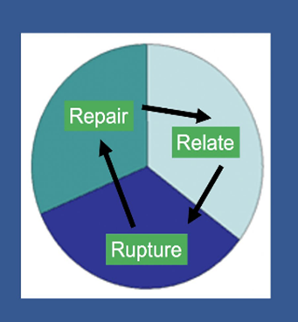
When examining each element of the Relate-Rupture-Repair cycle, we need to examine the specific skills we, as adults, can use to help support students with their interactions. We acknowledge that it’s ok to get things wrong because repair will happen. To define each part of the cycle;
- RELATE – the times in relationship when we feel connected and attuned with one another.
- RUPTURE – the times in relationship when there is misunderstanding or mis-attunement; when we don’t get it right and we feel like the relationship experiences a setback.

- REPAIR – involves correcting the misunderstanding or mis-attunement of the rupture by trying to share understandings of intentions, feelings thoughts and actions in order to return to relationship. This is undertaken through Intervention work with an adult, and may include other repair work post trigger presentation.
THE NURTURE-STRUCTURE HIGHWAY:
Both Nurture and structure are crucial for healthy development of a child. However, where each is taken to the extreme, this can become detrimental. Remaining nurturing and structured depends on negotiable and non-negotiable rules which can empower both adults and young people to contribute to a safe and consistent approach to behaviour.
The Nurture-Structure Developmental highway model, developed by Jean Illsley Clarke, provides a way of helping adults consider the best possible support for the young person and how to avoid veering off into extremes.
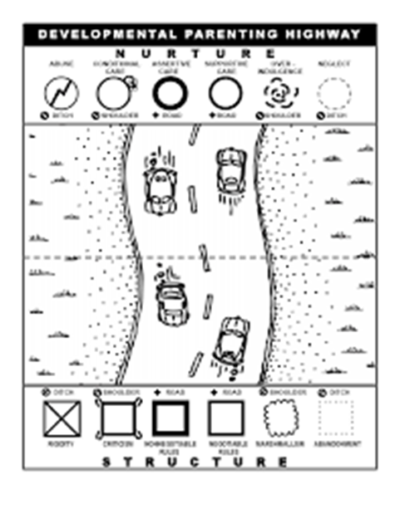

The metaphor of the highway serves to support the analogy of helping a young person stay steady in the middle of the road. This approach explores ‘therapeutic’ parenting as driving down the highway. When you stay in the centre lanes of the highway young people grow and thrive. To stay safe on the road you need a good set of front and back tyres – front tyres are the soft, nurturing side of parenting, back tyres are the firm, structured side. The best way to avoid overindulging young people or being too rigid is to avoid the shoulders and ditches. The middle of the highway is where the true power lies.
At Dovecote School we maintain a stance of supportive and assertive care which promotes clear boundaries and a ‘let’s do it together’ attitude, allowing flexibility through negotiable rules and ensuring boundaries and structure through non-negotiable rules.
15.4. Supporting Mental health & wellbeing.
To support each young person wellbeing and mental health, Dovecote School allocate a learning mentor/tutor to each child. The tutor’s role is to promote positive attachments and safety in relationship. Mentors meet and greet young people at the start and end of the day and provide check-ins across the school day if needed. Mentors are a go-to person for young people and adults. Dovecote School shares daily information with parents and carers to ensure difficulties are discussed and addressed and positive engagement is celebrated.
Dovecote School recognises that young people can come to the setting not yet able to recognise, manage or develop safety in relationship. To support with this the school has developed an Action-Response ladder which enables us to treat all young people fairly, although this may not be equally. Some children require more support to feel safe and learn to regulate than others and may require a range of interventions for this to happen. Learning about cause and effect is a key element of the understanding our Actions.
Dovecote School anticipates presentations that appear as bullying and promotes ‘non-negotiables’ approach to managing behaviours which can cause hurt and unsafe feelings or compromise child protection. Dovecote School recognises the need for young people to feel hooked into the school experience and to be able to ‘negotiate’ in order to take ownership of their learning and to develop skills for life.

NEGOTIABLE | NON-NEGOTIABLE
Individualised Reward systems ie: - Short term – lesson activity based with reward time at the end: Medium term – enrichment trips.  Strategies for regulation – what helps me to keep calm and regulated.  Working an animal – including animals as safe space.  Safe space/safe person – finding adults and spaces which help me when I’m anxious.  Activity choices (ie: choose from two maths worksheets)  Student council member ship promotes involvement of all students views around end of term celebrations, reward trips, some elements of environmental development (ie PE space), hook days.  Lunchtime activities  Lunch choices to suit personal taste and dietary/cultural needs.  Curriculum planning for Pathway 3 ie: ODE planning, subject choices for qualification. | Behaviours that are harmful and unsafe  Young people will give in all phones/tablets on arrival at school each day – these will be returned before leaving at 3pm  Young people will give in all smoking/vaping paraphernalia on arrival at school each day – these will be returned before leaving at 3pm  persistent Swearing,  No sexualised/racial/discriminatory comments  Consistently refusing lessons and low engagement  Verbal abuse towards others  Disruption to others learning  Climbing gates and fences, climbing through windows and other unsafe behaviour.  Throwing objects to hurt others/damage property.  Harming animals.  Threat to life and to others wellbeing

15.5. Losses in life & learning and the impact upon norm presentations:
Every year 20,000 children under the age of 16 years will be bereaved of a parent and many more will experience the death of someone else special in their life. In addition to these, individual pupils and or schools may also experience the death of a child at the school or a staff member. It is almost inevitable therefore, that at some time all schools will have to deal with a death that affects the school community. Death can also include the death of a family pet or for example a school animal (e.g.- horse, goat, etc…).
As children spend a large proportion of their time at school, teachers and staff members often become the primary source of care and support. Similar feelings of bereaved in children can also be triggered by the loss of a key staff member within the school community leaving.
Many students will therefore see our school as a safe haven away from the turmoil of emotions at home and will look to trusted staff members for help. Dovecote School acknowledges that the emotional and physical impact of loss for young people present differently. Young people who have experienced multiple school placements, a range of adults coming into and then leaving their lives can impact upon their resilience level and result in low self-esteem and negative mindset. This in turn, can becomes a barrier to learning. Thrive approach emphasises the importance of understanding the chemical dynamic of the brain and the grief cycle. At these points/ moments in time, student presentations may be triggered. Intervention work will be undertaken to support this.
Where news of a death needs to be shared in school, parents will be informed in the first instance and agreement reached about who will inform the young person and when. This will ensure a child-centred approach from trusted adults. Where news of staff departure (a natural part of school life) needs to be shared, school will inform parents before, then sharing the news themselves. Dovecote school acknowledges the need for many young people to have time to process this news. We promote adults who are leaving to support young people and each other through the relate-rupture-repair cycle to ensure everyone can maintain relationship during the lead up to the adult leaving.
There are interactions in the adolescent brain which can cause heightened responses to loss and grief. In addition, the interplay between feel-good chemicals and stress-related chemicals can cause erratic responses and difficulty regulating in times of stress:
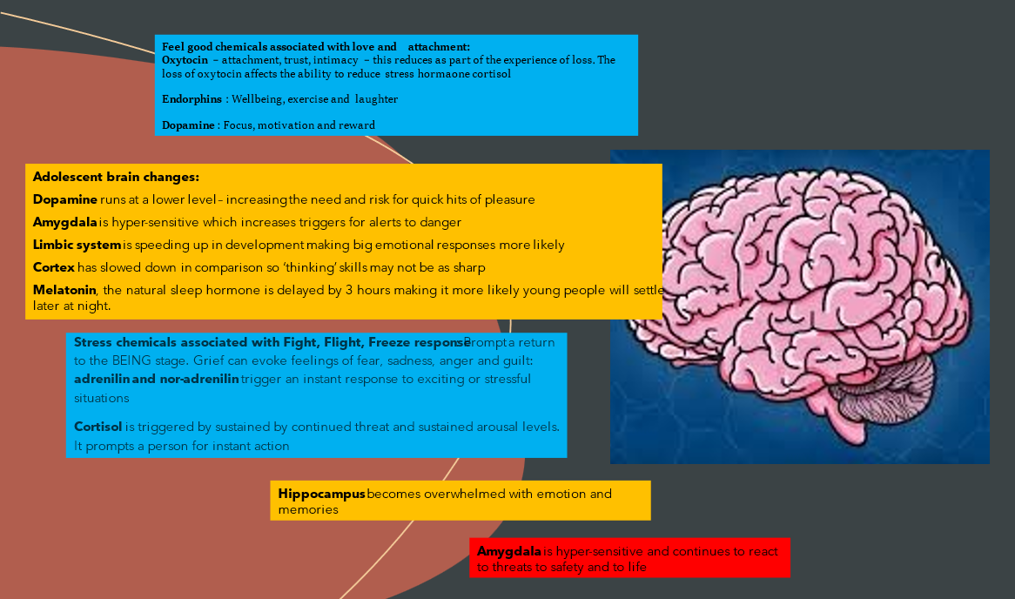
The tasks of grieving can be a dynamic process that is different for everyone. These tasks can take the following form:
- Acceptance
- Feeling
- Adjustment
- Re-investment emotionally in relationships
- Integrating the experience as part of their own narrative
As Therapeutic parents it is important to recognise the need for young people and each other to be able to ‘tell the story-tell the story-tell the story’, to be able to reach a point of integration of loss into our narrative. In the case of loss within the school community, the Leadership Team and staff Wellbeing team will ensure all staff receive regular check-in and offers of support to navigate the experience.
15.6. Guidance for Specific Incidents:
A). SAFE TOUCH: Dovecote School recognises that some young people need and benefit from safe and containing touch to promote safety in relationship. This may include full or side hugs (where both parties are comfortable and Attunement requires this) offering physical comfort for difficulties and/or pain and discomfort following accidents and, as a last resort, placing a young person in a physical intervention/hold to ensure the safety of them and others.
B). Where possible staff will offer/receive hugs and physical comfort with others around to observe. If this is not possible, staff will record the safe touch intervention as part of daily handover and will ensure they record preferred form of touch as a regulatory strategy on the student Individual Support Plan.
15.7 EXAMPLES OF SCRIPTS AND RESPONSES USED:
The Thrive Approach promotes consistency and repeated experiences in order to re-route or lay down pathways; supporting regulation and positive choice. The following scripted responses, in the form of the WING acronym, help Dovecote staff offer support to young people in a non-confrontational manner:
‘Wonder’ aloud what might be going on for a young person – ‘I’m wondering what’s going on for you’ or ‘I wonder if it would help to use the swing’
‘Imagine’ into their experience and what might be happening – ‘I imagine that might be because you’re tired’ or ‘I can imagine that felt really hard’
‘Notice’ the physical manifestation of their internal emotional landscape – ‘I can see that you are unhappy, you are angry and shouty’
‘Guess’ what thoughts might be happening or what might help – ‘I guess it could be because’ or ‘I’m guessing a drink might help right now’
Some young people may discharge their thoughts and feelings in an unsafe way and may endanger themselves and others. Adults can respond to this with a phased approach to setting boundaries:
- ‘I am asking you to…’
- ‘I am telling you to…’
- ‘I am going to help you to…’
Dovecote school ask staff to always remember to ‘Connect before you correct’. When working with students showing triggered presentations, staff will use a mix of Pro-active, Active and reactive approaches.
15.8 Proactive strategies employed by staff.
- Proactive strategies are those used within lessons as part of the daily routine and organisation, such as: -
- Talking to a young person in a calm and controlled manner, using his/her name first and a brief instruction.
- ‘First....then /now…. next’ (using visuals and symbols where appropriate).
- Having favoured choice activities available in class.
- Having a member of staff assigned to the young person.
- Organisation of the classroom, e.g. distracting toys not accessible, positioning of young people in class.
Advance warning of change of activity, e.g. count down; use of timer / music. Staff modelling appropriate behaviour.
- Praise for appropriate behaviour.
- Use of young person’s strengths and interests.
- Any person who comes into contact with a young person e.g. new staff are informed of what can happen and what strategies are in place to de-escalate situations to may occur.
- Active Strategies are those which are used when a young person is displaying signs of trigger presentations and consists of strategies used to defuse or de-escalate situations: -
  - Be aware of any warning signs that inappropriate behaviour may occur. Divert and distract by adding another activity or topic.
  - Display calm body language. Talk low, slow and quietly.
  - Use appropriate humour.
  - Continue to remind of appropriate behaviour. Offer alternatives and options.
  - Offer clear choices.
  - Give clear directions for a young person to stop.
  - Remind young people about rules and likely outcomes. Set clear enforcement limits.
  - Catch young people being good; use praise. Calmly and quietly repeat instructions.
  - ‘First....then ’ (using symbols) – first do required activity, and then receive favoured.
  - activity as reward.
  - Remove young people away from trigger and remove trigger.
  - Remove an audience or take vulnerable young people to a safer place.
  - Use safe defensive measures, guiding the young person away if he/she is trying to make physical contact.
  - Effect a ‘change of face’ with colleague(s)
  - Ensure that colleagues know what is happening and get help.
A well-chosen word can sometimes avert an escalating crisis. When young people are becoming angry, there is no point in getting into an argument. Telling people to calm down can actually cause more anxiety. Pointing out what the young person has done wrong can make things worse. The only purpose in communicating with an angry person is to prevent further escalation. It is better to say nothing and take time to choose your words carefully than to say the wrong thing and provoke a further escalation.
15.8.2 Reactive Interventions employed by staff.
These are the strategies that will be used if a student’s presentation escalates into a crisis situation, and could include the following:
- Make the environment safe. Move furniture.
- Remove objects that can be used as weapons.
- Guide assertively – hold or restrain if absolutely necessary. Change member of staff as needed.
- Planned ignoring.
- In a firm tone, repeat instructions.
- Inform the young person of consequences of their actions. Remove students to a safe area.
- Allow student time and space to :- Process information and respond Physically recover
- Talk about the incident
15.9 Risk Assessments
Any young person that displays regular medium or high-level presentations on the Action response ladder will Require an Individual Risk assessment. This will consider the identification of any activities or environments that are associated with risk, establish the likelihood of risk for an individual young person or young people, estimate the consequences of an unhelpful outcome and take steps to avoid unreasonable risk. Risk assessment should contain all relevant information and be regularly reviewed. In order to preserve the dignity and promote positive community presence of young people, staff must act to ensure that all reasonable measures are in place to reduce the risk of young people displaying challenging behaviour in public settings. Staff must carry identification with them when supporting young people in community settings and be prepared to explain, or otherwise communicate, the necessity of their actions.
Risk Assessments will be shared and discussed with parents / carers, at Parents’ Evening and Annual Review meetings, and some strategies may require parental support, e.g. young person being told that his/her parents will be called to take him/ her home once his/her presentations reach an agreed level. Where a young person’s presentations are considered to be unduly disruptive to others or causing distress to the student or themselves, regular withdrawal with either Outreach (community based or alternative) or home education will be used.

