Complaints Policy

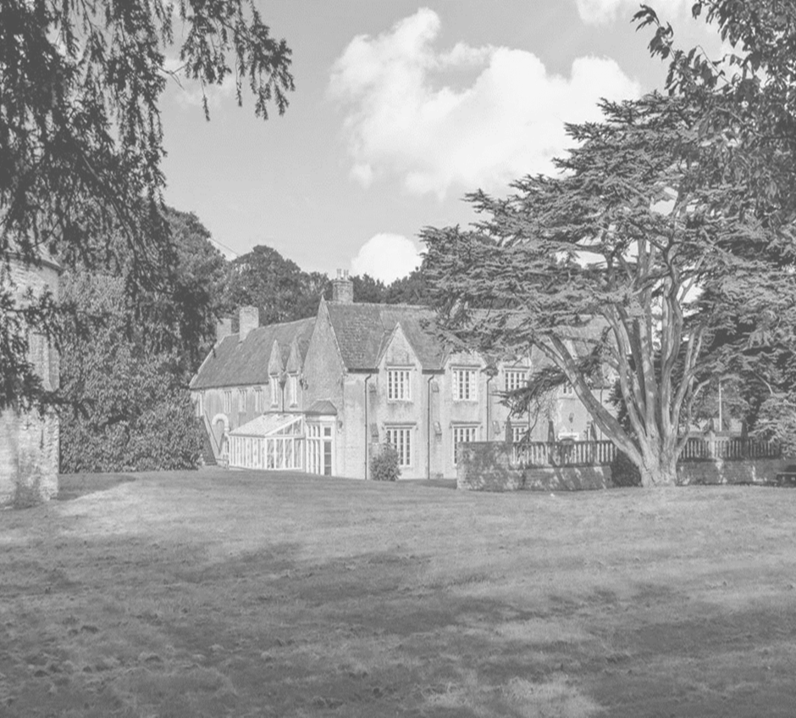
Approved by: | Jason Goddard | Date: 5TH January 2023
Last reviewed on: | 1st Jan 2023
Next review due by: | 28th January 2024

Statement of intent
- Legal framework
- Definitions
- Eligibility to make a complaint.
- Timescales
- Stage 1 – informal raising of a concern
- Stage 2 – formal complaint
- Stage 3 – panel hearing
- Recording complaints
- Monitoring and review

Statement of intent
Dovecote School aims to resolve all complaints at the earliest possible stage and is dedicated to ensuring all complaints are managed sympathetically and efficiently.
Any complaint or concern will be taken seriously, whether formally or informally, and the appropriate procedures will be implemented. This policy has been created to deal with any complaint against a member of staff, or the school as a whole, relating to any aspects of the school or the provision of facilities or services.

The school will ensure the complaints procedure is:
- Easily accessible and publicised on the school’s website.
- Simple to understand and put into practice.
- Impartial and fair to all parties involved.
- Respectful of confidentiality duties.
- Continuously under improvement, using information gathered during the procedure.
- Fairly investigated, by an independent person when necessary.
- Used to address all issues to provide appropriate and effective responses where necessary.

Legal framework
This policy has due regard to legislation including, but not limited to, the following:
- Education and Skills Act 2008
- The Education (Independent School Standards) Regulations 2014
- Equality Act 2010
- The UK General Data Protection Regulation (UK GDPR)
- Data Protection Act 2018
- Freedom of Information Act 2000
This policy will be implemented in accordance with the following school policies:
- Records Management Policy
- Grievance Policy

Definitions
For the purpose of this policy:
- A “complaint” can be defined as ‘an expression of dissatisfaction’ towards the actions taken or a perceived lack of action taken.
- A “concern” can be defined as ‘an expression of worry or doubt’ where reassurance is required.
- “Complainants” are those who have raised a concern or a complaint.
- A “grievance” is an issue raised by a member of staff where they feel the school has not implemented a policy or process fairly or properly. Grievances will be dealt with in line with the school’s Grievance Policy.
- For the purpose of this policy, concerns will be classed and addressed as complaints.
- For the purpose of this policy, “days” relate to school days.

Eligibility to make a complaint.
Parents (including individuals with parental responsibility) of students currently being educated at the school can make a complaint in line with this policy.
All complaints will be treated seriously and confidentially. Parents will be assured that their children will not be penalised if they raise a complaint.
This policy does not cover complaints made by the following:
- Parents of students who have left voluntarily or as a result of being excluded (expect where the complaints process was started when the student was still being educated at the school)
- Students
- Prospective students and their parents, and the failure to admit such students.

Timescales
Complaints are expected to be made as soon as possible after an issue arises to ensure the issue is addressed in an appropriate timescale.
The school upholds a three-month time limit in which a complaint can be lodged following an incident. Complaints made outside this time limit will not be automatically refused and exceptions will be considered.
Timescales for managing complaints at specific stages are outlined in the relevant sections of this policy. In the case of any timescales changing, all parties involved will be informed of the changes in a timely manner.

Stage 1 – informal raising of a concern.
The school expects that most concerns can be resolved informally.
Concerns should be raised initially as follows:
- Educational issues – raise the concern with the relevant teacher. The concern will be passed to a more senior member of staff if appropriate.
- Pastoral care – raise the concern with the headteacher.
- Behaviour – raise the concern with the staff member who imposed the behaviour sanction.
- Financial matters – raise the concern with the headteacher.
- Other concerns – raise the concern with the headteacher.
- Concerns regarding the headteacher – raise the concern with the CEO.
A complaint may be made in person, by telephone or in writing. A written record will be kept of all concerns and the date on which they were received. A concern provided in writing will be acknowledged by telephone or in writing within 2 days of receipt during term time and as soon as practicable during school holidays.
If the concern is not resolved within 5 days or, in the event that the complainant is not satisfied with the response to their concern, the complainant will be advised to proceed in accordance with stage 2 of this procedure.

Stage 2 – formal complaint
The complainant should submit their complaint in writing to the headteacher. The complaint will be acknowledged by telephone or in writing within 2 days of receipt during term time and as soon as practicable during school holidays, indicating that action is being taken and the likely timescales.
The headteacher will meet with the complainant within 5 days of acknowledging receipt of the complaint to discuss the matter. If the complaint is about the headteacher, the discussion will take place with the CEO.
During the meeting, the headteacher will attempt to reach a resolution; however, it may be necessary for further investigations to be carried out by the headteacher or another designated member of staff. If the complaint is about the headteacher, the CEO will arrange any necessary investigations.
Written records will be kept of all meetings and other communications held in relation to the complaint.
Once all facts are established, the headteacher will inform the complainant of their decision and their reasoning in writing.
If the complaint is about the headteacher, the chair of the proprietorial body will inform the complainant of their decision and their reasoning in writing.
The complainant will be informed of the decision within 10 days from the receipt of the complaint. Where there are exceptional circumstances resulting in a delay, the complainant will be notified of this and informed of the new timescales as soon as possible.
If the complainant is not satisfied with the outcome suggested, they will be advised to proceed to stage 3 of this procedure.

Stage 3 – panel hearing
Where a complaint cannot be resolved during stage 2, a hearing before a panel appointed by or on behalf of the school’s CEO will be arranged.
The panel will consist of at least three people who were not directly involved in the matters detailed in the complaint. One panel member will be independent of the management and running of the school – this means they are not a member of the school’s workforce or proprietorial body and are not otherwise involved in the management of the school, e.g. a solicitor who regularly acts for the school.
A hearing will be scheduled to take place as soon as practicable and normally within 10 days. Reasonable arrangements will be made to ensure the complainant can attend the panel hearing. If the complainant does not exercise the right to attend the panel hearing, the hearing will still be held.
The complainant will be informed that they are able to be accompanied at the hearing if they wish; however, legal representation will not normally be appropriate.
The right for a parent to be accompanied at a panel hearing does not confer a right on a parent to have a legal representative make representations on their behalf at a hearing, but the school will decide whether to allow this on a case-by-case basis.
If the panel deems it necessary, it may require that further details of the complaint or any related matters be supplied in advance of the hearing. Copies of such information will be supplied to all parties no later than 5 days prior to the hearing.
After considering all the relevant facts, the panel will make findings and recommendations. The decision, findings and recommendations will be provided to the complainant in writing within 5 days of the hearing. A copy of the decision, findings and recommendations will be sent to, where relevant, the person complained about, the headteacher and CEO
The decision of the panel will be final, and the completion of stage 3 represents the conclusion of the school’s complaints procedure.
If it is found that the school has not met its requirements in relation to managing complaints because of the way a particular complaint has been handled, the Secretary of State has no power to compel the school to alter its decision on that complaint, only to take regulatory action designed to address the failure to meet the complaints standard, so that future complaints are dealt with properly.

Recording complaints
A written record will be kept of any complaint made, detailing:
- Whether the complaint was resolved following an informal route, formal route or panel hearing.
- Actions taken by the school as a result of the complaint (regardless of whether the complaint was upheld).
Additional records may be kept containing the following information:
- The date the issue was raised.
- The name of the complainant and, where relevant, their child
- A description of the issue
- Records of all the investigations
- Witness statements
- The name of the staff member responsible for handling the issue at each stage
- Copies of correspondence on the issue
Correspondence, statements and records relating to individual complaints will be kept confidential except where the Secretary of State or a body conducting an inspection under section 109 of the Education and Skills 2008 Act requests to access them.

Monitoring and review
This policy will be reviewed annually. The next scheduled review date of this policy is 28th Jan 2024
All changes made to this policy will be communicated with all relevant stakeholders.

