Complaints Policy

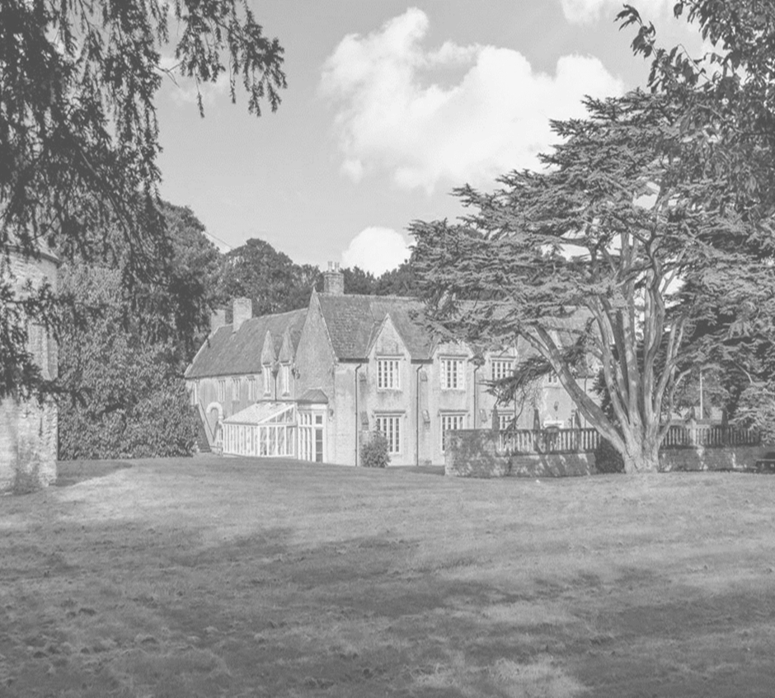

Approved by: Headteacher / Proprietor:
Date of approval:
Last reviewed: August 2025
This revision: May 2026 — ISI inspection response; timescale review; 33(3)(f) compliance; Group oversight provisions added
Next review due: August 2026
Applies to: Dovecote School — all staff, governors, and proprietorial body

Summary of Changes — May 2026 Revision

This policy was revised following an ISI inspection (April 2026), where one unmet standard was identified (33(3)(f) — complaints panel composition).

This revision:
- Ensures full compliance with ISI 33(3)(f)
- Extends operational timescales to realistic levels
- Introduces a formal Stage 3 trigger process
- Introduces a standing panel register
- Strengthens governance and group oversight

These changes ensure both compliance and practical implementation.

Statement of intent 3
The school will ensure the complaints procedure is: 4
1. Legal framework 4
1. Definitions 5
2. Eligibility to make a complaint. 5
3. Timescales 6
4. Stage 1 – informal raising of a concern. 6
5. Stage 2 – formal complaint 7
6. Stage 3 – panel hearing 7
7. Recording complaints 9
8. Monitoring and review 10
9. Alternative Procedures 10
10. Appendix 1 – Managing Unreasonable or Vexatious Complaint Behaviour 10

Statement of intent
Dovecote School aims to resolve all complaints at the earliest possible stage and is dedicated to ensuring all complaints are managed sympathetically and efficiently.
Any complaint or concern will be taken seriously, whether formally or informally, and the appropriate procedures will be implemented. This policy has been created to deal with any complaint against a member of staff, or the school as a whole, relating to any aspects of the school or the provision of facilities or services.

The school will ensure the complaints procedure is:
- Easily accessible and publicised on the school’s website.
- Simple to understand and put into practice.
- Impartial and fair to all parties involved.
- Respectful of confidentiality duties.
- Continuously under improvement, using information gathered during the procedure.
- Fairly investigated, by an independent person when necessary.
- Used to address all issues to provide appropriate and effective responses where necessary.
Complaints will be investigated based on the issues set out at the point of submission. New matters raised during an ongoing complaint may be considered separately under the procedure. The complaints procedure is not a mechanism for general correspondence, repeated debate of professional judgement, or for the introduction of new issues once an investigation is underway.
This policy forms part of a wider suite of policies across the Cavendish Education Group and should be read alongside safeguarding, equality, and data protection policies. The school is committed to using complaints as a source of learning and continuous improvement.

Legal framework
This policy has due regard to legislation including, but not limited to, the following:
- Education and Skills Act 2008
- The Education (Independent School Standards) Regulations 2014
- Equality Act 2010
- The UK General Data Protection Regulation (UK GDPR)
- Data Protection Act 2018
- Freedom of Information Act 2000
This policy will be implemented in accordance with the following school policies:
- Records Management Policy
- Grievance Policy

Definitions
For the purpose of this policy:
- A “complaint” can be defined as ‘an expression of dissatisfaction’ towards the actions taken or a perceived lack of action taken.
- A “concern” can be defined as ‘an expression of worry or doubt’ where reassurance is required.
- “Complainants” are those who have raised a concern or a complaint.
- A “grievance” is an issue raised by a member of staff where they feel the school has not implemented a policy or process fairly or properly. Grievances will be dealt with in line with the school’s Grievance Policy.
- For the purpose of this policy, concerns will be classed and addressed as complaints.
- For the purpose of this policy, “days” relate to school days.
- “Independent member” means a person who is not a member of the school’s workforce, not part of the proprietorial body, and not involved in the management or running of the school.

Eligibility to make a complaint.
Parents (including individuals with parental responsibility) of students currently being educated at the school can make a complaint in line with this policy.
All complaints will be treated seriously and confidentially. Parents will be assured that their children will not be penalised if they raise a complaint.
This policy does not cover complaints made by the following:
- Parents of students who have left voluntarily or as a result of being excluded (expect where the complaints process was started when the student was still being educated at the school)
- Students
- Prospective students and their parents, and the failure to admit such students.
This policy does not apply to concerns that are subject to separate statutory procedures, including safeguarding matters, staff grievances, admissions or exclusions.
The school will not normally consider complaints made on behalf of another individual unless appropriate consent has been provided.
Complaints relating to safeguarding, admissions, exclusions, or staff grievances will be managed under separate statutory procedures.

Timescales
All timescales refer to school days unless otherwise stated.
Stage 1:
- Acknowledgement: within 5 school days
- Resolution/escalation: within 5 school days
Stage 2:
- Acknowledgement: within 5 school days
- Meeting: within 10 school days of acknowledgement
- Written outcome: within 15 school days of receipt
Stage 3:
- The Stage 3 process will begin with a trigger checklist completed within 2 school days.
- The hearing will then be scheduled within 20 school days of this trigger.
- Decision issued: within 5 school days

These timescales may be varied in exceptional circumstances. Any delay will be communicated clearly to all parties.

Stage 1 – informal raising of a concern.
The school expects that most concerns can be resolved informally. All Stage 1 concerns must be logged centrally.
Concerns should be raised initially as follows:
- Educational issues – raise the concern with the relevant teacher. The concern will be passed to a more senior member of staff if appropriate.
- Pastoral care – raise the concern with the headteacher.
- Behaviour – raise the concern with the staff member who imposed the behaviour sanction.
- Financial matters – raise the concern with the headteacher.
- Other concerns – raise the concern with the headteacher.
- Concerns regarding the Headteacher should be raised with the Chair of the Proprietorial Body.
A complaint may be made in person, by telephone or in writing. A written record will be kept of all concerns and the date on which they were received. A concern provided in writing will be acknowledged by telephone or in writing within 5 days of receipt during term time and as soon as practicable during school holidays.
If the concern is not resolved within 5 school days, or the complainant remains dissatisfied, they will be advised to proceed to Stage 2.

Stage 2 – formal complaint
The complainant should submit their complaint in writing to the headteacher. The complaint will be acknowledged by telephone or in writing within 5 school days of receipt during term time and as soon as practicable during school holidays, indicating that action is being taken and the likely timescales.
The headteacher will meet with the complainant within 10 school days of acknowledging receipt of the complaint to discuss the matter. If the complaint is about the headteacher, the discussion will take place with the proprietorial body.
Written records will be kept of all meetings and other communications held in relation to the complaint.
Once all facts are established, the headteacher will inform the complainant of their decision and their reasoning in writing.
If the complaint is about the headteacher, the chair of the proprietorial body will inform the complainant of their decision and their reasoning in writing.
The complainant will be informed of the decision within 15 school days from the receipt of the complaint. Where there are exceptional circumstances resulting in a delay, the complainant will be notified of this and informed of the new timescales as soon as possible.
The written response issued at the end of Stage 2 constitutes the conclusion of Stage 2 of the complaint’s procedure. If the complainant remains dissatisfied, they may request progression to Stage 3 within the timescale set out in this policy. The complainant must request escalation to Stage 3 within 10 school days of receiving the Stage 2 written outcome.
A written outcome must be issued at the conclusion of Stage 2. Stage 3 cannot be triggered without a formal written Stage 2 outcome.

Stage 3 – panel hearing
Where a complaint cannot be resolved during Stage 2, a hearing before a panel appointed by or on behalf of the proprietorial body will be arranged.
Panel Composition
The panel will consist of at least three members:
- None of whom have been directly involved in the matters detailed in the complaint
- At least one member must be fully independent of the management and running of the school

An independent member is defined as a person who is not a member of the school’s workforce, not part of the proprietorial body, and not otherwise involved in the management or running of the school.
Failure to meet these requirements constitutes a breach of the Independent School Standards.
Standing Panel Register
The school maintains a standing panel register of suitable panel members, including independent members.
This register:
- Is maintained in coordination with Cavendish Education
- Contains a minimum of four individuals
- Is reviewed termly to ensure availability and compliance

Stage 3 Trigger Process
Within 2 school days of a complaint being escalated to Stage 3, the Complaints Lead will:
- Confirm panel members have been identified
- Confirm the independent member
- Set a hearing date
- Ensure all documentation from Stage 2 is collated

Hearing Arrangements
A hearing will be scheduled to take place within 20 school days of Stage 3 being triggered.
Reasonable arrangements will be made to ensure the complainant can attend the panel hearing. If the complainant does not attend, the hearing will still proceed.
The complainant may be accompanied at the hearing; however, legal representation will not normally be appropriate. Any request for legal representation will be considered on a case-by-case basis.
If required, the panel may request further details in advance of the hearing. Pre-hearing papers: at least 5 school days before the hearing
Decision
After considering all the relevant facts, the panel will make findings and recommendations.
The decision, findings and recommendations will be provided to the complainant in writing within 5 school days of the hearing. A copy will also be provided to the relevant staff member(s), the Headteacher, and the proprietorial body where appropriate.
The decision of the panel is final and represents the conclusion of the school’s internal complaints procedure.
Finality of Process
The outcome issued following Stage 3 concludes the school’s complaints procedure. The school will not normally re-open complaints once the process has been exhausted unless significant new evidence is provided.
If it is found that the school has not met its regulatory requirements in the handling of a complaint, the Secretary of State has no power to overturn the decision but may take regulatory action to ensure future compliance.

Recording complaints
The school maintains a central complaints log including:
- Dates of receipt, acknowledgement, and resolution
- Stage progression
- Actions taken
- Outcomes
- Panel composition (where applicable)

All Stage 3 documentation must include:
- Trigger checklist
- Panel membership confirmation (including independence)
- Decision record

The Cavendish central team reviews complaints data regularly.
A termly Complaints Review Group monitors themes, trends, and compliance.

Monitoring and review
Governors will:
- Review complaints data termly
- Confirm policy compliance
- Ensure availability of independent panel members
- Monitor adherence to timescales

Failure to implement policy in practice will be treated as a governance issue.
This policy will be reviewed annually. The next scheduled review date of this policy is 1st August 2026
All changes made to this policy will be communicated with all relevant stakeholders.

Alternative Procedures
Certain complaints may be managed under alternative procedures, including:
- Safeguarding concerns
- Staff grievances
- Admissions and exclusions

Where this applies, the complainant will be directed to the appropriate policy.

Appendix 1 – Managing Unreasonable or Vexatious Complaint Behaviour
This appendix should be read alongside the complaint's procedure above. It does not form a stage of the complaints process but provides guidance on managing behaviour that may interfere with the effective operation of the procedure. The school may implement proportionate measures where complainant behaviour becomes unreasonable, without affecting the substance of the complaint.
Dovecote School recognises the right of parents and carers to raise concerns and complaints. However, in line with Department for Education guidance on managing complaints and unreasonable behaviour, the school distinguishes between the substance of a complaint and the behaviour displayed while pursuing that complaint.
Unreasonable or vexatious behaviour is characterised by the nature or frequency of contact rather than the merits of the complaint itself.
Examples may include:
- Persistently raising the same issues after they have been investigated and responded to
- Refusing to accept the outcome of the complaints process
- Submitting excessive or disproportionate correspondence
- Adding new allegations outside the scope of the current complaint stage
- Making personal allegations against staff without evidence
- Using aggressive, intimidating or accusatory language
- Seeking to pressure staff outside agreed processes
Where behaviour is deemed unreasonable, the school may take proportionate steps to manage future contact. These may include limiting communication to a single point of contact, restricting correspondence to writing, declining to respond to matters already concluded, or requiring new concerns to be submitted separately under this policy.
Any measures taken will be proportionate, documented, and focused on behaviour rather than the substance of the complaint. These measures do not prevent a complainant from raising new complaints in line with this policy.
The school reserves the right to implement proportionate management measures at any stage of the complaints process where behaviour meets the threshold described above.

