Accessibility Plan

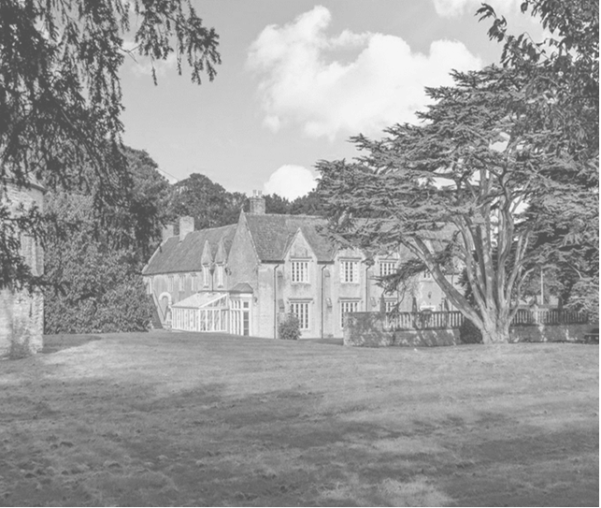

|  |  |  |
| --- | --- | --- |
| **Approved by:** | **Neil Gage** | **Date: 1st September 2025** |
| **Last reviewed on:** | **1st August 2025** | |
| **Next review due by:** | **1st August 2026** | |

**Contents:**

Statement of intent

1. Legal framework
2. Roles and responsibilities
3. The Accessibility Audit
4. Planning duty 1: Curriculum
5. Planning duty 2: Physical environment
6. Planning duty 3: Information
7. Monitoring and review

**Statement of intent**

This plan outlines how Dovecote School aims to increase access to education for students with disabilities in the three areas required by the planning duties in the Equality Act 2010 (i.e., the curriculum, physical environment and information).

A person is regarded as having a disability under the Equality Act where they have a physical or mental impairment that has a substantial and long-term adverse effect on their ability to carry out normal day-to-day activities.

This plan aims to:

* Increase the extent to which students with disabilities can participate in the curriculum.
* Improve the physical environment of the school to enable students with disabilities to take better advantage of education, benefits, facilities and services provided.
* Improve the availability of accessible information to students with disabilities.

The above aims will be delivered within a reasonable timeframe, and in ways which are determined after taking into account students’ disabilities and the views of parents and students. In the preparation of an accessibility strategy, the LA will have regard to the need to allocate adequate resources in the implementation of this strategy.

The CEO also recognises its responsibilities towards employees with disabilities and will:

* Monitor recruitment procedures to ensure that individuals with disabilities are provided with equal opportunities.
* Provide appropriate support and provision for employees with disabilities to ensure that they can carry out their work effectively without barriers.
* Undertake reasonable adjustments to enable staff to access the workplace.

The plan will be resourced, implemented, reviewed and revised in consultation with:

* Students’ parents.
* The headteacher and other relevant members of staff.
* CEOs.
* External partners.

1. **Legal framework**

This plan has due regard to all relevant legislation and statutory guidance including, but not limited to, the following:

* Human Rights Act 1998
* The Special Educational Needs and Disability Regulations 2014
* Education and Inspections Act 2006
* Equality Act 2010
* Education Act 1996
* Children and Families Act 2014
* The Equality Act 2010 (Specific Duties and Public Authorities) Regulations 2017
* DfE (2014) ‘The Equality Act 2010 and schools’
* DfE (2015) ‘Special educational needs and disability code of practice: 0 to 25 years’

This plan operates in conjunction with the following school policies:

* Equality Information and Objectives Policy
* Early Years Policy
* Special Educational Needs and Disabilities (SEND) Policy
* Equality, Equity, Diversity and Inclusion Policy
* Admissions Policy
* Behaviour Policy
* Supporting Students with Medical Conditions Policy
* Administering Medication Policy
* Health and Safety Policy
* Data Protection Policy

1. **Roles and responsibilities**

The CEO will be responsible for:

* Ensuring that all accessibility planning adheres to and reflects the principles outlined in this plan.
* Approving this plan before it is implemented.
* Monitoring this plan.

The headteacher will be responsible for:

* Ensuring that staff members are aware of students’ disabilities and medical conditions.
* Establishing whether a new student has any disabilities or medical conditions which the school should be aware of.
* Consulting with relevant and reputable experts if challenging situations regarding students’ disabilities arise.
* Working closely with the CEO, LA and external agencies to effectively create and implement the school’s Accessibility Plan.

The SENCO will be responsible for:

* Working closely with the headteacher and CEO to ensure that students with SEND are appropriately supported.
* Ensuring they have oversight of the needs of students with SEND attending the school and advising the headteacher in relation to those needs as appropriate.

Staff members will be responsible for:

* Acting in accordance with this plan at all times.
* Supporting disabled students to access their environment and their education wherever necessary, e.g., by making reasonable adjustments to their practice.
* Ensuring that their actions do not discriminate against any student as a result of their disability.

1. **The Accessibility Audit**

The CEO will undertake an **annual** Accessibility Audit. The audit will cover the following three areas:

* **Access to the curriculum** – the CEO will assess the extent to which students with disabilities can access the curriculum on an equal basis with their peers.
* **Access to the physical environment** – the CEO will assess the extent to which students with disabilities can access the physical environment on an equal basis with their peers.
* **Access to information** – the CEO will assess the extent to which students with disabilities can access information on an equal basis with their peers.

When conducting the audit, the CEO will consider all kinds of disabilities and impairments, including, but not limited to, the following:

* **Ambulatory disabilities** – this includes students who use a wheelchair or mobility aid
* **Dexterity disabilities** – this includes those whose everyday manual handling of objects and fixtures may be impaired
* **Visual disabilities** – this includes those with visual impairments and sensitivities
* **Auditory disabilities** – this includes those with hearing impairments and sensitivities
* **Comprehension** – this includes hidden disabilities, such as autism and dyslexia

The findings from the audit will be used to identify short-, medium- and long-term actions to address specific gaps and improve access.

All actions will be carried out in a reasonable timeframe, and after taking into account students’ disabilities and the preferences of their parents. The actions that will be undertaken are detailed in the following sections of this document.

**[Please note that the actions in the tables below are examples only. You must amend the content of the tables to reflect your school’s actions.**

# Planning duty 1: Curriculum

|  |  |  |  |  |  |  |
| --- | --- | --- | --- | --- | --- | --- |
|  | **Issue** | **What** | **Who** | **When** | **Outcome** | **Review** |
| **Short term** | Staff members do not know whether the curriculum is accessible | Audit of the curriculum | Headteacher, teachers, SENCO | Spring 2025 | Management and teaching staff are aware of the accessibility gaps in the curriculum | Summer 2025 |
| Staff members do not have the skills to support students with SEND | INSET provided to staff members  Training for teachers on adapting the curriculum | Headteacher, external advisors, SENCO | Summer 2024 | Staff members have the skills to support students with SEND | Autumn 2025 |
| **Medium term** | School trips do not take into account students with SEND | Needs of students with SEND are incorporated into the planning process | Teachers, SENCO | Spring 2025 | Planning of school trips takes into account students with SEND | Summer 2025 |
| **Long term** | Students with SEND cannot access lessons  Our school uses a range of communication methods to ensure information is accessible. This includes:   * Internal signage * Large print resources * Induction loops * Pictorial or symbolic representations * Assistive Technology | Provide Assistive Technology  and other adjustments for students with SEND  All students have access to a full-time, need-led curriculum which is specifically developed to overcome barriers to learning and promote personal progress. | Headteacher, SENCO | Autumn 2024 | Students with SEND can access lessons | Spring 2025 |

# 

# Planning duty 2: Physical environment

|  |  |  |  |  |  |  |
| --- | --- | --- | --- | --- | --- | --- |
|  | **Issue** | **What** | **Who** | **When** | **Outcome** | **Review** |
| **Short term** | Management does not know if the school’s physical environment is accessible  The environment is adapted to the needs of students as required. This includes:   * Disabled parking bays   Library shelves at wheelchair-accessible height.  Café, toilet and classroom facilities at ground floor level. | Audit of physical environment | Building surveyors | Spring 2025 | School is aware of accessibility barriers to its physical environment and will make a plan to address them | Summer 2025 |
| **Medium term** | Learning environment of students with visual impairments is not accessible | Incorporation of appropriate colour schemes  Painting of handholds and step edges to highlight change of flooring. | SLT | Summer 2025 | Learning environment is accessible to students with visual impairments | Autumn 2025 |
| Toilets are not accessible | Handrails installed | SLT | Summer 2025 | Access to toilets is increased | Autumn 2025 |
| **Long term** | Children with physical disabilities cannot access school buildings | Construction work undertaken | SBM/building contractors | Summer 2025 | School buildings are fully accessible | Autumn 2025 |

# Planning duty 3: Information

|  |  |  |  |  |  |  |
| --- | --- | --- | --- | --- | --- | --- |
|  | **Issue** | **What** | **Who** | **When** | **Outcome** | **Review** |
| **Short term** | Management staff do not know whether school information is accessible | Audit of information and delivery procedures | SENCO, ICT manager | Spring 2025 | School is aware of accessibility gaps to its information delivery procedures | Summer 2025 |
| School does not know how to make written information accessible | Schools seeks advice from external advisors | SENCO | Summer 2025 | School is aware of local services for converting written information into alternative formats | Autumn 2025 |
| **Medium term** | Written information is not accessible to students with visual impairments | Provide written information in alternative formats  Incorporate appropriate colour schemes when refurbishing and install window blinds | SENCO, ICT manager | Spring 2025 | Written information is fully accessible to children with visual impairments | Summer 2025 |
| **Long term** | School website is not accessible to children with SEND | Audit of website | ICT manager | Summer 2025 | Website is fully accessible | Autumn 2025 |

# Monitoring and review

This plan will be reviewed on an **annual** basis by the CEO and headteacher. The next scheduled review date for this plan is **August 2026** Any changes to this plan will be communicated to all staff members and relevant stakeholders.

**Written by Sian Gage August 2025**